  - England and Wales

Foundation Trainee Pharmacist Recruitment

Applicant Handbook
  - For programmes commencing 2024
Version 1, 15 May 2023

Classification: Official
Publication reference: May 2023

Contents
Foreword 3
1. Introduction 4
1.1 General Overview for 2024 recruitment 5
1.2 Recruitment timeline 6
1.3 Applying for Foundation Training commencing in 2024 7
1.4 Employers participating in the England and Wales Foundation Training Recruitment Scheme 7
1.5 Employers participating in the Scotland Foundation Training Recruitment Scheme 8
2. Before you apply 9
2.1 Eligibility to apply 9
2.2 Overseas applicants – Eligibility 10
2.3 Accessing the Oriel System 10
2.4 Viewing Foundation Training programmes on Oriel 12
2.5 Contacting you 14
2.6 Getting ahead of the game 14
3. Applying for a Foundation Training programme 16
3.1 Completing the application form 16
3.2 Reasonable adjustments 24
3.3 Special circumstances 24
4. Preferencing Foundation Training Programmes 25
4.1 What is preferencing? 25
4.2 Terminology: programmes, places and placements 27
4.3 Programme information 28
4.4 Preference categories 29
4.5 Health and Justice Trainee Pharmacist Cross Sector Placements 30
4.6 Skilled Worker Visa sponsorship 31
4.7 Filters 31
4.8 Bulk preferencing 33
5. Processing applications and selection centres 34
5.1 Longlisting 34
5.2 Situational Judgement Test (SJT)/Numeracy Invitation to selection centre 34
5.3 Expenses 35
5.4 Selection Centres – methods of assessment 36
5.5 SJT/Numeracy centre documentation 40
5.6 Scoring guidance 41
6. Offers process 44
6.1 Offer responses 45
6.2 Upgrading 46
6.3 Enhanced preferencing and offers 48
6.4 Holding an Offer: For applicants applying to both National and Scotland Vacancies only 49
6.5 What happens after accepting an offer 50
6.6 Contacting Your Employer 50
6.7 Withdrawing from an Oriel offer 51
7. Enquiries 53
8. Useful Links 55
Appendix A: Foundation Training Person Specification 2024 entry 56
Appendix B: Job Description (2024 entry) 58
Appendix C: Foundation Training Professional Attributes Framework (PAF) 60
Appendix D: Reasonable Adjustments (2024 entry) 65
Appendix E: Foundation Training Special Circumstances Policy (2024 entry) 68
Appendix F: Regions and Sectors 84

Foreword
Welcome to the Applicant Handbook, which supports the England and Wales Foundation Training National Recruitment Scheme.
NHS England (Health Education England has now merged with NHS England) and Health Education and Improvement Wales have been working with pharmacy employers, students and trainees, training providers and recruitment specialists to develop a recruitment system which is transparent, fair and robust. The Scheme uses tried and tested IT systems and selection methodologies and provides a mechanism for all first iteration job offers to be issued on the same day. We recognise that students will have different reasons for wanting to train in different sectors or areas of the country and to support this we have developed an enhanced preferencing system designed to maximise choice.
We encourage you to provide feedback to ensure we continuously improve the experience we offer you.
Good luck with your application!
Atif Shamim
Professional Lead for National Foundation Training Recruitment

1. Introduction
Applying for a Foundation Training programme is an important decision and can seem like a daunting task. There are many factors to consider when thinking about where you would wish to complete your training. The General Pharmaceutical Council (GPhC) website provides comprehensive information about Foundation Training and its requirements.
The aim of the National Recruitment Scheme is to have a fair, equitable and transparent recruitment process for all. Applying through the online portal (Oriel) requires you to submit one application in order to apply for all Foundation Training places in Wales and all those places based in hospitals in England. Many primary care pharmacy employers in England (i.e. community pharmacy) have also chosen to opt into the scheme, including a number of multi-sector Foundation Training posts, particularly with general practice.
More information about which employers are included is available in section 1.4 of this handbook.
This Foundation Training Recruitment Applicant Handbook is designed to provide the necessary information to support you in making a successful application to Foundation Training programmes commencing in July/August 2024. The sections of this handbook are set out to follow the stages of the national application process in chronological order as far as possible. The handbook also explains how to access the online application system (Oriel) and what information you need to provide to support your application.
Representatives from the British Pharmaceutical Students’ Association (BPSA) as well as employers have helped us put this handbook together to ensure all the important points are covered.
The Pharmacy National Recruitment Office (PNRO) is hosted by the NHS England London and Kent, Surrey and Sussex Healthcare Education Team and manages recruitment into Foundation Training programmes across England and Wales.
The Oriel Applicant User Guide will be available for Oriel system-specific guidance via the Helpdesk section of the Oriel system shortly.
The England and Wales Foundation Trainee Pharmacist Recruitment website is updated regularly with the latest application information; we recommend that you visit this regularly to ensure you stay up to date, in particular the National Recruitment Student Zone page.
If your query cannot be answered by the information found on the website or through this Applicant Handbook, please go to the Enquiries and Support portal. The Enquiries Portal has a FAQ function which we would advise you to look through before submitting an enquiry.

1.1 General Overview for 2024 recruitment
England and Wales
Applicants for programmes starting in 2024 will be assessed using SJT and numeracy tests. Further information on these methodologies can be found later in this handbook.
Scotland
NHS Education for Scotland (NES) will continue with the same approach and applicants for training posts in Scotland will also be assessed using SJT and numeracy tests.
Applying for a training place
If you wish to apply to posts across England, Wales and Scotland you must apply to both the England and Wales vacancy and to the Scotland vacancy on Oriel. However, you will only be required to sit the SJT and numeracy tests once and your score will be used in both applications.
Recruitment for Scotland uses a separate vacancy on Oriel so please ensure that you apply for the correct vacancy for the area you wish to train in. Further information is available via NHS Education for Scotland. You may apply to both the Scotland and the England and Wales vacancies if you wish.

IMPORTANT: This document contains guidance on the process for applying to England and Wales only. If you have questions regarding the process in Scotland please contact NES directly.

1.2 Recruitment timeline
Key dates are listed below. Further detail regarding each of these steps is provided later within this handbook.

Recruitment Activity | Date
Oriel applications open | 7th June 2023 (12:00pm GMT)
Oriel applications close | 21st June 2023 (12:00pm GMT)
Foundation Training programme information available on Oriel | 7th June 2023
Preferencing window opens | 26th July 2023
Invitation to SJT/numeracy selection centre opens | 2nd August 2023
Invitation to SJT/numeracy selection centre closes | 16th August 2023
SJT/Numeracy selection centre held | 21st September 2023 – 5th October 2023
Preferencing window closes | 31st October 2023
Comms to unsuccessful students | 1st November 2023
First iteration of offers made | 8th November 2023
Offers hold deadline | 24th November 2023
Offers upgrade deadline | 29th November 2023
Programmes commence | July/August 2024

Please note that all dates above are subject to change and we recommend you check the National Recruitment Website for any updates.

1.3 Applying for Foundation Training commencing in 2024
Applications open at 12:00pm GMT (UK local time) on 7th June 2023 and close at 12:00pm GMT (UK local time) on 21st June 2023.
IMPORTANT: Late applications will not be accepted under any circumstances.
- All applications must be made via the Oriel recruitment portal using the nationally agreed application form.
- You can register on the Oriel system before you apply but please note that registering on the recruitment portal is only the first step, and a confirmation of this registration will automatically be sent to you. Subsequent to this confirmation, you must complete and submit the actual application by the deadline. Please refer to the additional guidance, which can be accessed via the Helpdesk section of the Oriel system.
- Communication between the PNRO and you will be primarily via Oriel/email. You should check your email account and Oriel account a minimum of once every 48 hours. Failure to do so may result in your missing vital information in relation to your application. Please also check spam or junk-mail to ensure correspondence has not been filtered by your provider.
- You will only need to submit one application.
- You will not be asked to provide a supporting statement to demonstrate that you meet the person specification as part of your online application.

1.4 Employers participating in the England and Wales Foundation Training Recruitment Scheme
All Hospital Foundation Training programmes in England and all training programmes in Wales will be recruited to via the Oriel system. A large number of primary care pharmacy training programmes in England are also being recruited to via this process. Community pharmacy programmes that are included will be clearly identifiable within the Oriel system; they can be identified and filtered as Primary Care programmes.
Wales will only be offering multi-sector programmes. In Wales all trainees are employed by NHS Wales Shared Services Partnership (NWSSP) through a single lead employment model. This means irrespective of the programme you preference your terms and conditions of employment are the same. Please note in Wales as well as information being shared with the employer, your information will be shared with the host organisations and Health Education and Improvement Wales (HEIW).
A full list of the programmes will be available to view from 7th June 2023 via the Oriel system by selecting the Pharmacy Programmes option from within the pharmacy staff group.
IMPORTANT: Some primary care (community pharmacy and general practice) employers in England will recruit outside of the Oriel system. These will be advertised independently by individual employers and do not form part of this application process. If you are interested in applying for any of these programmes it will be necessary for you to submit a separate application as per individual employer guidance/ timelines.
All employers and host organisations participating in the National Recruitment Scheme are required to sign up to NHS England’s Terms of Participation, which include adherence to Health Education England’s Quality Framework and Standards which can be viewed here. This sets out the standards that trainees can expect within their training programmes. In addition to the quality framework in Wales, all host organisations sign a training agreement with HEIW and HEIW quality manage all host organisations.

1.5 Employers participating in the Scotland Foundation Training Recruitment Scheme
Scotland has its own employer registration process, for more details please visit this website. Scotland will be using the same selection methods as England and Wales and will follow the same recruitment timeline. Specific dates will be provided by the recruitment team at NHS Education for Scotland. This means that you will only be required to sit the assessment once to be eligible for both vacancies.
Applicants who apply to both the National and Scotland vacancy will need to preference within each vacancy.

2. Before you apply

2.1 Eligibility to apply
Before beginning your application, it is important to determine whether you are eligible to apply. You must meet certain eligibility criteria in order to be considered for Foundation Training programmes.
IMPORTANT: We strongly advise that you read the Person Specification, Job Description and Professional Attributes Framework before starting an application. (See Appendices A, B, and C).
Applicants who are eligible to apply for the national Foundation Training programmes via this recruitment process are as follows:All current third year UK MPharm undergraduates*
- UK MPharm graduates
- Overseas Pharmacists Assessment Programme (OSPAP) students
- OSPAP graduates
- Bradford sandwich students**

* Any current third year UK MPharm student who has not consented for their School of Pharmacy to provide their details as requested by the PNRO will not be eligible to apply
** Bradford sandwich students will apply to Oriel via their own vacancy, which is separate to the national vacancy. Guidance will be provided to these students via Bradford University. For further information please contact fls-placements@bradford.ac.uk
The following applicant types are not eligible to apply:
- European Economic Area (EEA) Pharmacist or an EEA Pharmacist requiring adaptation training
- Applicants who have failed their registration assessment once and are awaiting a second attempt
- Applicants who have banked any training with the GPhC.

Please note that the duration of all training programmes recruited to is 12 months (except for Bradford Sandwich programmes).
Pharmacy careers advice and support is available on both the GPhC website and the Health Careers website.
Further advice can be obtained from the Pharmacist Support website and enquiry line.

2.2 Overseas applicants – Eligibility
Some pharmacy graduates will require a work visa to enable them to undertake Foundation Training in the UK. It is the graduate’s own responsibility to ensure that they follow the government’s visa processes correctly.
For visa and immigration guidance please visit https://www.gov.uk/government/organisations/uk-visas-and-immigration. Please be aware that the PNRO will not be able to provide any advice regarding immigration queries.

2.3 Accessing the Oriel System
You can register on the Oriel system at any point to familiarise yourself with the system before applying when the application window opens (7th June 2023).
To access and register you will need to visit Oriel and select the pharmacy programme staff group.
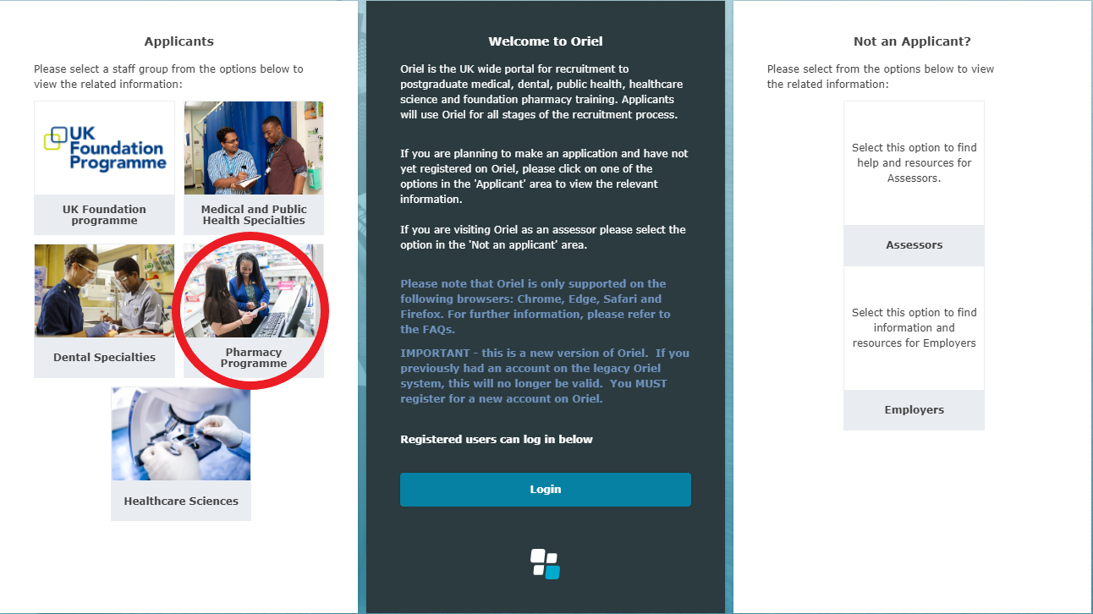
When registering, current MPharm students will need to ensure their forename and surname are entered in the same way as this information has been provided by their School of Pharmacy (SoP) and is the same as indicated in their passport/main identification documents. If you need to check the information that was provided by your SoP please contact them directly.
IMPORTANT: Any third year UK MPharm student who has not given their SoP permission to go onto a nominee list will not be eligible to apply for a Foundation Training programme through the Oriel system.
Once you have registered you will be able to log into your Oriel account using your email address with the password you have created. You will also be able to navigate around your own personal dashboard, which is where you are able to view all messages sent from Oriel and review your application.
Upon registering you will be asked to provide your personal details. Please ensure you provide your full name as indicated in your passport/main identification and provided by your SoP. This is used throughout the recruitment process and consistency is imperative.
IMPORTANT: You will be asked to enter your email address. This address is the primary means of contact between applicant and the PNRO so it is imperative that the address you enter is one that you check on a regular basis and is valid until the end of the recruitment process (NB: including outside of term time). After the offers process is complete employers may send written correspondence to the postal address of their successful applicant, so it is important that the postal information you enter is up-to-date and valid until the end of the recruitment process.
From 7th June 2023 until 21st June 2023, you should complete and submit the rest of the application form. All sections of the application form must be completed and submitted before the deadline (see below for further details on individual sections). The only information you will be able to change after 21st June 2023 is the order of your preferences, your referee details, and your personal contact details.
IMPORTANT: Please ensure you have a working internet connection. We recommend you submit your application in plenty of time and well before the final deadline. Late submissions will not be permitted.
Further details on how to complete each section of the application are provided in section 3.1 of this handbook.
We encourage you to register before the application window opens (7th June 2023 – 21st June 2023), for the following reasons:
- To familiarise yourself with the Oriel system.
- The personal section of your application can be completed as part of registration. This will be saved on the system and brought forward into your application, saving you time during the application window.

IMPORTANT: If you are locked out of your Oriel account and are unable to unlock it yourself, please contact the PNRO immediately via the Enquires and Support Portal and they will be able to unlock it on your behalf. The PNRO will aim to do this within 24 hours (excluding weekends and Bank Holidays).
Please note your account only locks after five failed attempts at logging into your account, or five failed attempts at resetting your password.

2.4 Viewing Foundation Training programmes on Oriel
From 7th June 2023 you will be able to see all the Foundation Training programmes being recruited to via the England and Wales National Recruitment Scheme. We strongly recommend that you look through these as early as possible to get an idea of the types of programmes on offer and what you might be interested in applying for.
To view the Foundation Training programmes, you will need to select Pharmacy Programmes from the main menu bar within Oriel.
Once you have selected Pharmacy Programmes you will be able to use a number of filters to help narrow down the programmes that are displayed to you. The filters are as follows:
- Recruiting for*
- Training Programme**
- Employer Name
- Employer Type (hospital or primary care***)
- Size of organisation (for primary care (community pharmacy) employers only – number of branches)
- Specialty (for hospital only)
- Skilled Worker Visa
- Region
- Location (at county/sector)
- Number of placements

* Please note this filter is to be used to differentiate between training programmes being offered in England & Wales and Scotland.
**As you will be applying to the national vacancy, you must ensure this filter is set to ‘Foundation Pharmacy’ only. Selecting this option will allow you to see the programmes that are entered into the National Recruitment Scheme. By selecting ‘Foundation Pharmacy Sandwich’ you will see the programmes entered into the Bradford sandwich vacancy.
IMPORTANT: Unless you are a second year Bradford sandwich student you should not be looking at programmes that fall under the Foundation Pharmacy Sandwich filter (screen shot below). Only second year Bradford sandwich students are eligible for these programmes
*** Please note that primary care relates to community pharmacy and General Practice employers.
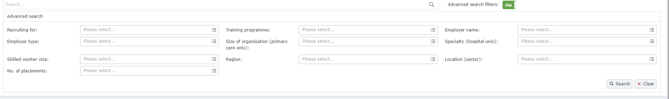
By clicking on View full programme details within a programme you will be able to view the full programme details.
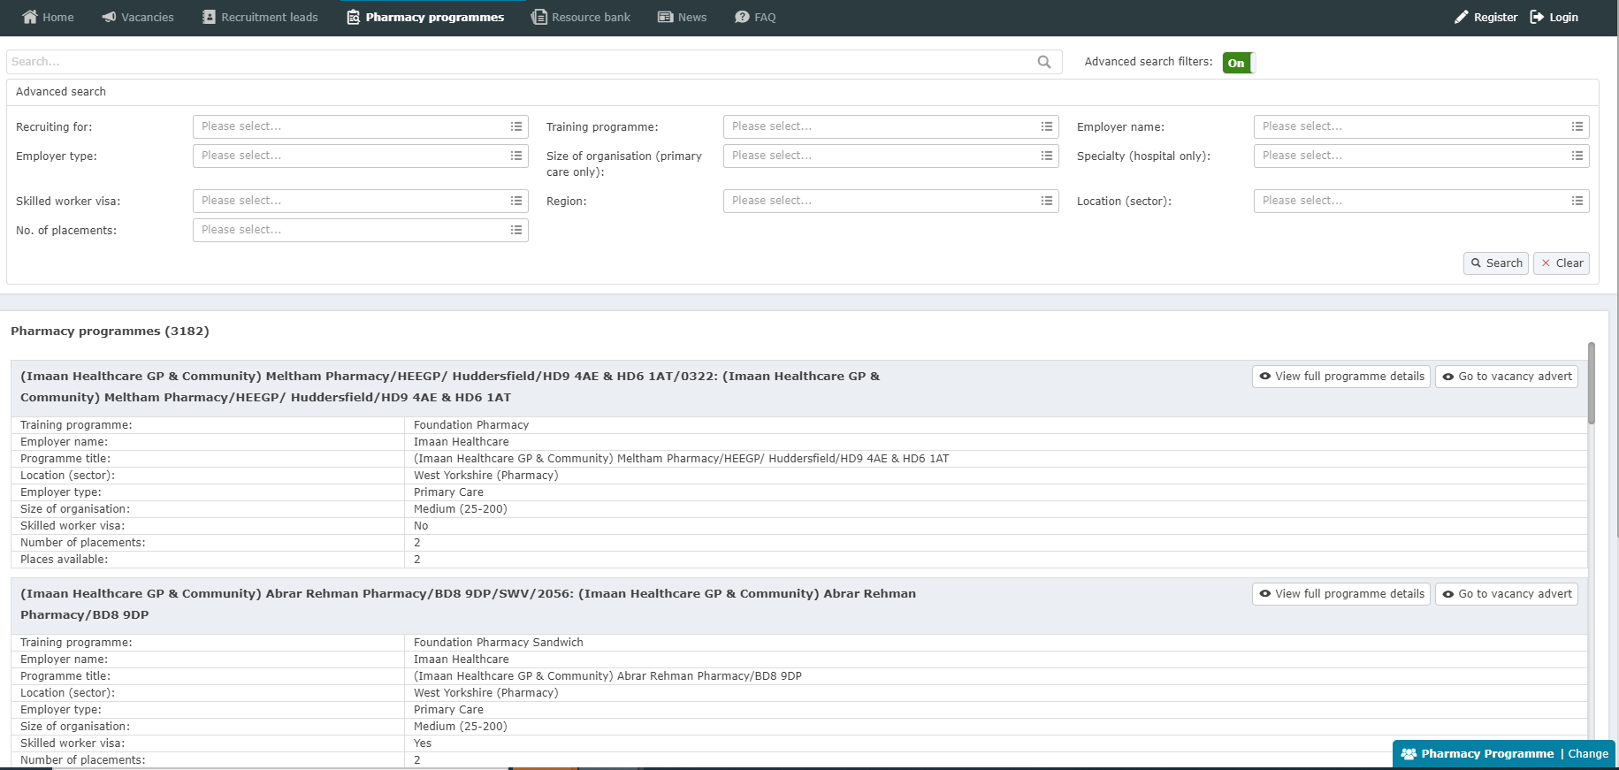

2.5 Contacting you
Remember to check your email and Oriel account every 48 hours throughout the process. We will endeavour to use your email address to prompt you to check your account for information at relevant times throughout the application process, but it is crucial that you also log in to Oriel directly to view messages as e-mail can be wrongly directed into spam or junk folders. The PNRO is not responsible for applicants missing any important information or deadlines as a result of messages not being checked. If you need to change your email address for any reason, use the My Profile option on Oriel. The PNRO may need to text you during the application process, so it is important to make sure the mobile number you enter as part of your application is an active one.
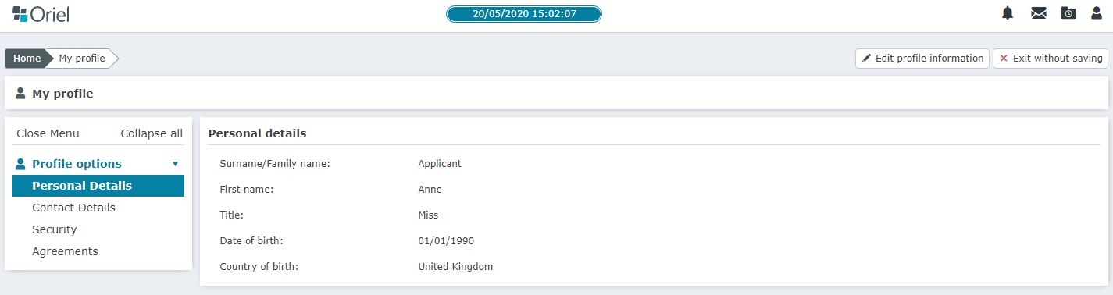

2.6 Getting ahead of the game
Before you start your application, we strongly recommend you take the following actions:
- Note the recruitment timelines/deadlines.
- Ensure your full name is the same as your passport/main identification and that provided by your SoP (if applicable).
- Collate any evidence you may be required to upload as part of your application e.g. pharmacy degree certificate if you are an MPharm graduate or OSPAP confirmation/evidence if you are about to undertake an OSPAP qualification.
- Current third year MPharm students: you should ensure you know your student ID number as you will be asked for this as part of your application.
- Ensure you have read the person specification, job description and Foundation Training professional attributes framework.
- If applicable, ensure you are aware of how your visa requirements will affect your application.
- Identify and contact your referees.
- Ensure your passport is valid (in date) as this will be required as part of the document checking process during your assessment.
- Start viewing the programmes early. These will be available from 7th June 2023. All the programmes available can be viewed by selecting the Pharmacy Programme from the main menu within Oriel and by visiting the Foundation Training national recruitment website.

3. Applying for a Foundation Training programme

3.1 Completing the application form
IMPORTANT: You must ensure you select the Foundation Pharmacy – Pharm vacancy when applying.
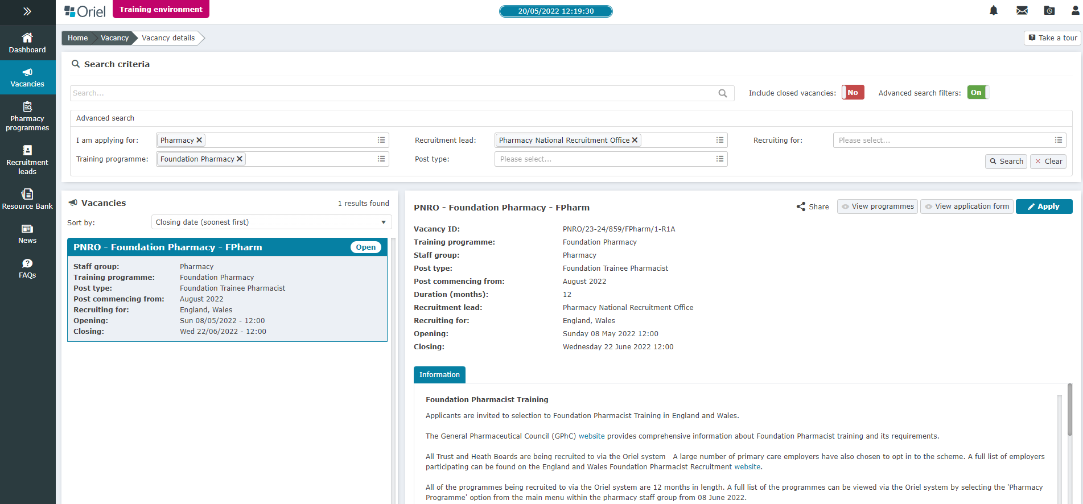
You can use the ‘Training Programme’ filter to select ‘Foundation Pharmacy’. The ‘Foundation Pharmacy Sandwich – Pharm’ is for Bradford sandwich students only. Please note that the system will prevent you from applying against the wrong vacancy.
You must submit an application between 7th June and 21st June 2023. The Foundation Training application form is divided into 8 sections.
Each section is displayed across the top of the screen on the Oriel system and is further explained below:
- Personal
- Eligibility
- Fitness to practise
- References
- Competences
- Employment
- Equality
- Declaration
The Oriel system will allow you to save and return to your application at any point during the application window (7th June 2023 – 21st June 2023). You do not have to complete and submit your application in one attempt. However, you must ensure that you submit your application before the deadline.
IMPORTANT: When you select “submit,” the page will change on Oriel informing you that you have submitted your application and you will also receive an email confirming that you have successfully submitted an application. You will only be able to edit your contact details, referee details and preferences (during the preferencing window) from this point onwards.
The following headings represent the different sections within the application form and provide you with the information and detail you will need in order to complete these sections; we recommend you read through this section in advance of completing the application form.
1. Personal
This section of the application will only be used for employment and identification purposes. The information you will be asked to provide includes:
- Your personal details, e.g., name, address, telephone numbers*, etc.
- If you would like to request special circumstances (please see section 3.3 of this handbook for further information).
- If you would like to request reasonable adjustments at a Selection centre (please see section 3.2 of this handbook for further information).
- We will also ask you to enter the type of applicant you are in this section. The type of applicant you are will determine the documentation we will require you to provide as part of your application. Please see section 2.1 of this handbook for the types of applicants who are eligible to apply.

*You must ensure this information is up to date, checked regularly and ensure your full name is the same as your passport/main identification documents and the name provided by your SoP (if applicable).

Current UK MPharm students
Current third year UK MPharm students will be asked to enter the following information:
- School of Pharmacy (SoP) name (from a drop-down list)
- Student University ID

This information and your forename and surname will be verified against the nominee list provided by your SoP so it is essential that the information you enter matches this. If you need to check the information that was provided by your SoP please contact them directly or check your online student record.
Current third year UK MPharm students will not be asked to upload any documentation to support the Personal section as part of their application.
IMPORTANT: Any third year MPharm student who has not given their SoP permission to go onto a nominee list will not be eligible to apply for a Foundation Training programme through the Oriel system.

UK MPharm Graduates
MPharm graduates will be asked to upload a copy of their MPharm certificate to the Oriel system as part of their application.

Current OSPAP students
Current OSPAP students will be asked to upload a copy of their letter from the GPhC confirming their eligibility to apply to an OSPAP programme and their SoP OSPAP acceptance letter

OSPAP Graduates
OSPAP graduates will be asked to upload a copy of their OSPAP Postgraduate Diploma or Masters certificate.
Please note: all requested documentation needs to be uploaded to the personal section of your application.
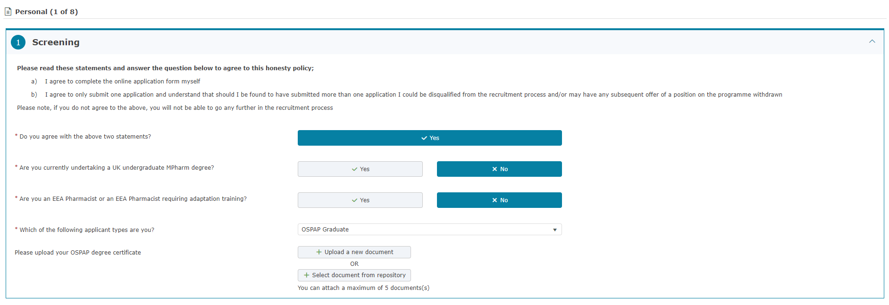
Important: We would encourage all applicants who are required to upload documentation to collate it in advance of the application window to save time during this process.
2. Eligibility

Professional Registration
This section of the application is where you declare if you hold or have ever held a professional registration with a statutory organisation. A statutory organisation is a professional regulator e.g. the General Pharmaceutical Council (GPhC) or General Medical Council (GMC).
Please note this information is not used as part of your application but is passed onto your employer/host organisation if you are successful.

Language Requirements
If your undergraduate training was not in English, you will be asked to provide details of your International English Testing System (IELTS) or Occupational English Test (OET) score.
For IELTS, you must have achieved as a minimum the following scores in the academic lnternational English Language Testing System (IELTS) in a single sitting within 24 months at time of application: Overall 7.0, Speaking 7.0, Listening 7.0, Reading 7.0, Writing 7.0. More information can be found here.
For OET, you must have achieved as a minimum the following scores in the Pharmacy Occupational English Test (OET) in a single sitting within 24 months at time of application: Speaking - B, Listening - B, Reading - B, Writing - B. More information can be found here

Right to work in the UK
In this section you will be asked to indicate your nationality (country pertaining to your nationality) and answer the relevant questions around your right to work in the UK. You will also be asked to provide details of your current immigration status (personal status).
Please note:
- You should refer to the UK Visas & Immigration website for up-to-date information regarding the right to work in the UK.
- Please be aware that the PNRO is unable to provide any advice regarding immigration queries.
- For Visa and immigration guidance please visit https://www.gov.uk/government/organisations/uk-visas-and-immigration.

For updated information relating to Brexit and the EU Settlement Scheme, please visit: https://www.gov.uk/settled-status-eu-citizens-families
Not all the programmes included in the recruitment scheme will be available to applicants requiring a Skilled Worker Visa (SWV). These programmes will be clearly identified to you through the preferencing page of the application with the use of SWV within the programme preference title (Please refer to section 4.5 of this guide for further details).
If you require a Skilled Worker Visa for your Foundation Training Year you may only preference and be offered posts by employers/host organisations which can sponsor a SWV.
If you will be applying via the Graduate Visa route, all programmes will be available for you to preference. However, in all cases, and regardless of the route of application, please note that immigration checks will form part of the pre-employment checks and it is your responsibility to ensure you have an up-to-date visa status and documentation. If it is found during pre-employment checks that you do not meet the eligibility requirements, the employer can withdraw their offer.

Graduate Eligibility
MPharm and OSPAP graduates must have completed their degree within 8 and 4 years respectively to be eligible to apply.

3. Fitness to Practise
In this section of the application, you will be asked to provide details of any unspent and spent convictions, investigations and/or warnings into fitness to practise.
IMPORTANT: Fitness to Practise information is collected on behalf of employers and host organisation as part of pre-employment checks and will be passed on to relevant employers by the PNRO once a programme offer has been accepted. Fitness to practise information is not reviewed as part of the application process.
You will not need to submit any further information relating to Fitness to Practise questions.
Please note if you have declared you have breached the Fitness to Practice conduct, any offer made is conditional. Fitness to Practice is part of pre-employment checks.
4. References
You are required to provide details of two referees as part of your application. One of these must be an academic reference. The other reference can be either:
- Employment or
- Character

If you have previously been employed, it is expected that you will provide an employment rather than character reference.
Referees should be contacted in advance to ensure they are happy to provide a reference on your behalf.
Referees will not be contacted before you have accepted an offer and the upgrading window is complete.
IMPORTANT: References are collected on behalf of employers as part of pre-employment checks and both references and referee contact details will be passed on to relevant employers/host organisation by the PNRO once a programme offer has been accepted. References are not reviewed as part of the application process. Offers of employment are, however, subject to receipt of satisfactory references.
Referees will be asked to provide references electronically via the Oriel system. Once references are requested referees will receive an email from the Oriel system.
Referee FAQs are available on the Enquiries and Support Portal.

Helping your referees
If your referee is unable to complete the reference in Oriel, this can be managed by yourself and your future pharmacy employer directly, outside of the Oriel system. Once all employers receive their confirmed trainee information you will contact them to go over any details that may need to be addressed prior to the post starting, such as contracts. As your placement is between you and the employer, it is acceptable to send references to them directly if needed. In the event that you have any references which have not been submitted on Oriel after the reference submission window closes, please contact your employer directly to discuss providing appropriate references.
5. Competences
In this section you will be asked to provide details of your primary pharmacy qualification, and the date of achievement. If you have not yet completed your primary pharmacy qualification i.e., MPharm degree or equivalent, please enter the date as the anticipated date of achievement.

OSPAP applicants
If you have completed or are currently undertaking an OSPAP qualification you will be asked to enter the name of the institution at which you are undertaking the qualification and date of achievement. If you have not yet completed your OSPAP qualification, please enter the date as the anticipated date of achievement.
6. Employment
In this section you will need to enter any employment details that you have had up to the start date of the programme (July/August 2024). It may be that you have no employment history as of the date you are applying as you are still a student, in which case answer yes to ‘I have no employment history.’
You are able to enter details of both paid and voluntary work. Do not include details of placements undertaken as part of your MPharm or OSPAP programmes.
IMPORTANT: Information relating to your employment history will not be used to assess your application. This information is collected on behalf of employers/host organisations.
If you have employment gaps the system will allow you to enter the reason for the gap and the date which it covers. The reason for having a gap can be simply that you returned to your studies, or that you went travelling. This information will not be used to assess your application.
7. Equality
This section includes equal opportunities monitoring information required by the health service to monitor their recruitment practices. The fields are mandatory, but you may choose the option ‘I do not wish to disclose’. This information will not be used to assess your application. Equal opportunities monitoring information is collected on behalf of employers and will be passed on to relevant employers/host organisations by the PNRO once a programme offer has been accepted. It will also be used to review equality within selection processes.
8. Declaration
In this section you will be required to confirm that you have read and understood several declarations. Oriel will prevent you from submitting your application until all sections of the application form have been completed. Please note the Oriel system will not allow you to submit an application without completing all the declarations.
By entering your details on Oriel, you are agreeing to this data being shared with, amongst others, your School of Pharmacy (if applicable) and being used in any evaluation studies related to Foundation Training recruitment and for quality assurance of programmes (including information being shared with relevant third parties if required).
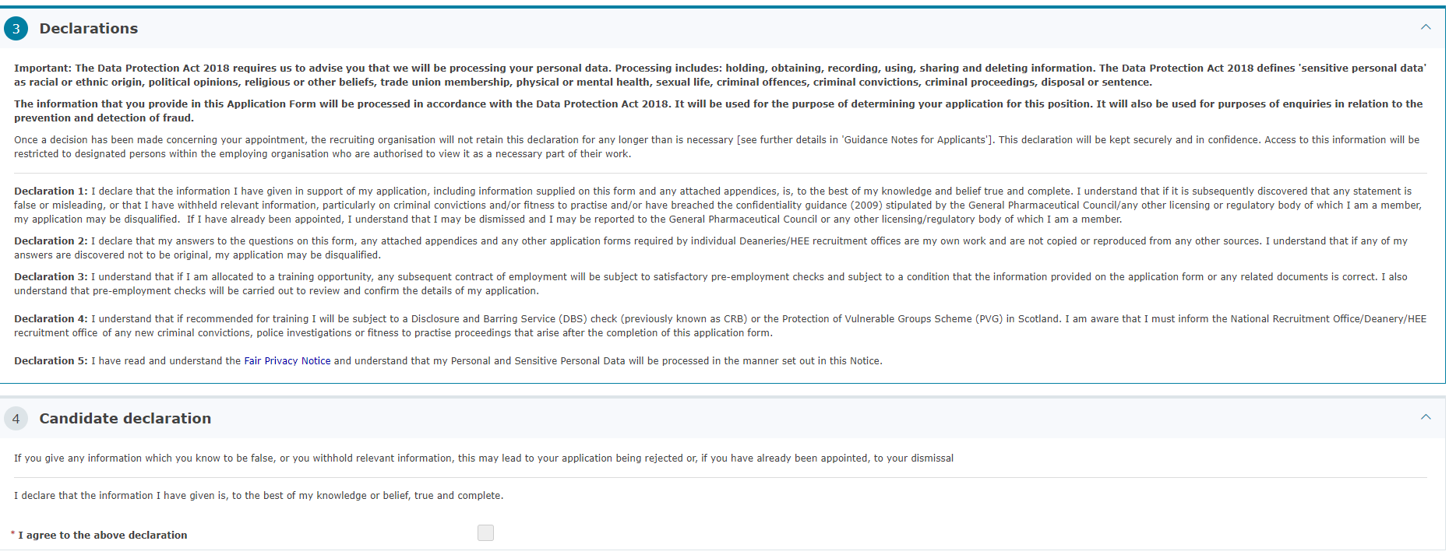
Once your application is accepted, you will receive an email via Oriel confirming it has been submitted successfully. You will be able to access your submitted application through your dashboard. You will be able to view your entire submitted application but can only amend your personal details, referee details and preferences (during the preferencing window) after submission.
IMPORTANT: You should ensure that you submit your application well in advance of the application deadline to avoid any last-minute problems e.g. with your local PC or internet connection that may prevent you submitting it.
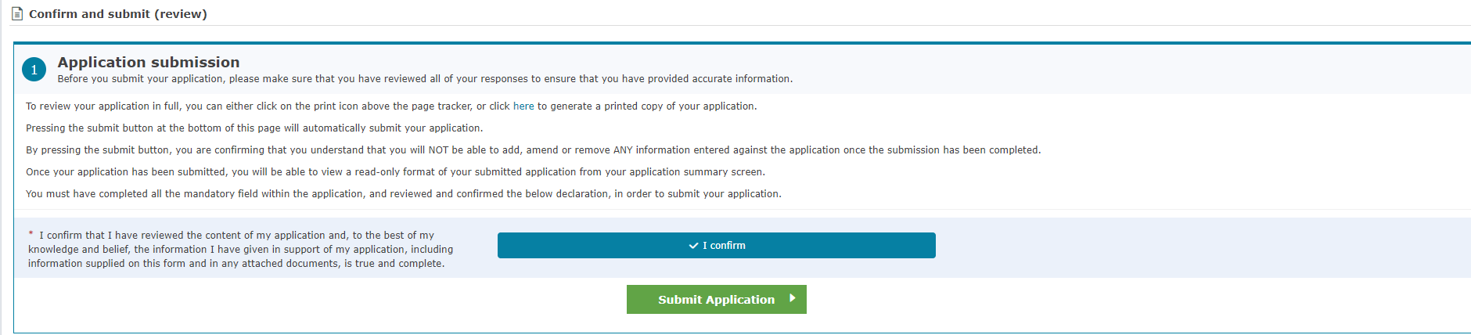
Remember: LATE APPLICATIONS WILL NOT BE ACCEPTED UNDER ANY CIRCUMSTANCES.
Please note that support is available via Enquiries and Support Portal Monday to Friday, 09:00 – 17:00 GMT (UK local time). This is particularly important if you are submitting your application from overseas where there may be a significant time difference.

3.2 Reasonable adjustments
If you wish to request reasonable adjustments during the recruitment process, you should read Appendix D and fill in the Request for Adjustments section on your application form.
The application form and supporting documentation should be submitted by no later than 12:00pm GMT (UK local time) on 21st June 2023.
Please note, your approval is only for the application process. Any adjustments you would require for your training post, must be discussed, and arranged with your future employer.
If you have a situation that has occurred post the application window closing, please contact us via the Enquiries and Support Portal to receive further guidance.

3.3 Special circumstances
As part of the Foundation Training Recruitment Scheme, a formal process has been introduced to support applicants with special circumstances and a requirement to be placed in a particular region for their training. If you wish to request special circumstances, you should read the policy: Trainee pharmacists (England and Wales) Special Circumstance Policy and fill in the Request for Special Circumstances form online. (Please see Appendix E).
The form and supporting documentation should then be completed via Enquiries and Support Portal by no later than 21st June 2023.
IMPORTANT: Requesting reasonable adjustments or special circumstances will not negatively impact on your application. These policies are to enable NHS England/ HEIW to provide the appropriate support to those applicants that need it.

4. Preferencing Foundation Training Programmes

4.1 What is preferencing?
Preferencing is the process by which you choose and rank the programmes that you are interested in applying for through the Oriel system.
A large number of places are being recruited to, so it is extremely important that you give yourself enough time to review and think about what type of programme you are interested in undertaking.
In previous years, a number of applicants were not offered places because they did not preference enough programmes or only those that were extremely popular. There were also applicants that were made offers against preferences they were not 100% happy to undertake. To avoid these preferencing issues, we recommend thinking carefully about the programme content before preferencing; are you happy with the hours? Is the commute reasonable/economical? These are just a couple of the factors you should be considering.
IMPORTANT: All programme information can be viewed from 7th June 2023 via the Oriel system. You must take care and attention to preference accurately. ONLY preference those programmes and locations that you would be happy to train in.
We strongly recommend that you start reviewing programmes before the preferencing window (26th July – 31st October 2023). You may also wish to undertake some research such as visiting employer websites or attending open days. Links to the websites for all employers offering training programmes as part of the recruitment process will be available as part of the programme information, where provided.
Analysis from previous years showed that Hospital and multi-sector/spilt placements places were very competitive, which was reflected in the high fill rate. You should therefore preference as widely as possible, taking into consideration the points stated above, to maximise your chance of securing a place through the scheme.
For further information about preferencing and fill rates from previous recruitments, please refer to the National Foundation Training recruitment website.

When is the preferencing window and what do I need to do?
The preferencing window is the time period during which you will be asked to preference all the Foundation Training programmes you are willing to accept.
During this period, you will need to log onto your Oriel account, access the preferencing page of your application and choose the programmes you are willing to accept.
The preferencing window is open between 26th July – 31st October 2023. You will be notified via the Oriel system when the preferencing window is open.
Please click here to view a video guide on how to preference.
IMPORTANT: You will have access to the programme information via the ‘Pharmacy Programmes’ section of the Oriel system from 7th June 2023. We would strongly advise you to start reviewing programmes at the earliest point to save time during the preferencing window.

Enhanced preferencing
Enhanced preferencing comes into effect after offers have been made. It is designed to provide an opportunity for applicants to change their preferences at a very late stage.
For applicants who have accepted a programme, there will be an option to select upgrade options which not only includes programmes that were originally ranked higher than the offered programme, but also those that were ranked lower. Applicants who have not received an offer will have the ability to amend their preferences up until the final round of offers. This includes re-ranking programmes from within the ‘Preference‘ category or moving preferences from within the ‘No Preference’ and ‘Not Wanted’ categories (for further information about preferencing categories see section 4.4 of the handbook).
Enhanced preferencing will take place between offer rounds and applicants will be informed via Oriel when this functionality is available. Further information on enhanced preferencing and offers can be found in section 6.3.

4.2 Terminology: programmes, places and placements
You will see the words programme, places and placements used in reference to your preferencing. Please see the table below for an explanation of each:
Term | Description
Programme | The programme is the Foundation Training position that is being offered to you. All programmes are 12 months in length (Unless you are applying for the Bradford sandwich vacancy).
Places | Places relates to the number of trainees that can be appointed to a programme. Some programmes can accommodate only a single trainee whereas other programmes may have multiple trainees undertaking an identical training programme.
Placements | Training programmes may be made up of a single placement of 12 months or of smaller constituent parts.  Placements represent a constituent part of a programme. They reflect the practice setting you will be undertaking your training in.  A placement is a minimum of three months in length.  Programmes can have a maximum of four placements within them.  Placements may be, for example, in the following practice settings:  Integrated Care Systems  General Practice  Hospital  Primary Care  Health and Justice (Prison)  Mental Health  Industry

4.3 Programme information
Every programme being recruited to through the recruitment process will be listed in the preferencing section of the application. Programmes will be displayed as preference codes and will be presented in the following way:
Name of main employer*/Town/Postcode/Unique code
For example: NORTH BRISTOL NHS TRUST/Bristol/BS10 5NB/0001
Please note: If a programme is able to sponsor a Skilled Worker Visa applicant, they will have a SWV within their programme preference code (please refer to section 4.5 of the handbook for further information).
*For Wales this will be Host Organisation
IMPORTANT: If you are not subject to any visa restrictions you will be able to preference all of the listed programmes, including the programmes that are marked as SWV.
You will be able to download and export a spreadsheet version of all the programmes being recruited to from the preferencing section of the application.
By clicking on the preference code, you will be able to the view the following information about each of the programmes available as part of the recruitment process:
- Employer/host organisation name
- Programme title
- Programme description
- Region
- Location (county/sector)
- Employer type
- Size of the community pharmacy organisation (defined by number of branches)
- Whether that employer is a licensed Skilled Worker Visa sponsor or not
- No. of placements
- Places available
- Salary
- Training provider
- Employer website
- Hours per week as per employment contract

IMPORTANT: Programme information is correct at time of publication but is subject to change until verified by employing organisations.

4.4 Preference categories
The preference section presents you with three categories which you are able to move your preferences between:
- No Preference
- Not Wanted
- Preference

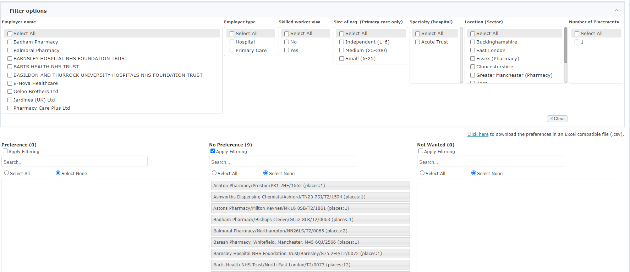
When you first look at the preferencing section of your application all the programmes listed will sit within the No Preference category.
No Preference: All the programmes will initially sit in this category. This will mean that you are willing to accept any of these programmes should you not be successful in being offered any of your positively preferenced programmes. They will not be offered to you in any set order as they are not ranked in this section. If there are programmes which you are most interested in, you are advised to rank these within the Preference category.
Not Wanted: This is the category you should move all the programmes you are not willing to accept into. You will never be made an offer to any of the programmes you move into this category after you have submitted your preferences.
Preference: This is the category you should move all the programmes you would actively like to be considered for. You will need to rank all of the programmes you move into this category starting with the number 1. This number indicates the order in which you would like the programme to be considered. If you are unable to rank programmes, leave them in the no preference section.
IMPORTANT: You may have as many programmes in each category as you wish however, the more programmes you preference, the higher the chances are that you will receive an offer.
Remember, any programme within your ‘Preference’ or ‘No Preference’ category could be offered to you, so you must be sure that you are willing to work for the employer at the location(s) specified. You should, for example, check to see how long it will take you to get to the site(s) via the method of transportation you plan to use when you begin your training.

4.5 Health and Justice Trainee Pharmacist Cross Sector Placements
NHS England are supporting a national expansion of Trainee Pharmacist placements within Health and Justice (H&J). The placements will be for a 13-week period starting in 2024.
It is hoped these placements will provide trainees with a unique patient facing experience working as part of a multidisciplinary team.
All placements will be cross sector placements and trainees will be hosted either by an acute trust, mental health trust or community pharmacy. i.e., they will have more than one placement.
Search for HMP (His Majesty’s Prison) within ORIEL to find these placements. Each H&J placement will have the name of the prison site documented in the programme description.
For further information on Health and Justice placements please contact:
england.hjpharmacyworkforce@nhs.net

4.6 Skilled Worker Visa sponsorship
Applicants who require a Skilled Worker Visa sponsor will be able to filter out all the programmes that cannot support their application through the preferencing section and should move them to the Not Wanted category.
Not all the programmes available in the recruitment process will be able to accommodate applicants requiring a Skilled Worker Visa. These programmes will be clearly marked to applicants and will not be offered under any circumstances. All the programmes that are able to support Skilled Worker applicants will have SWV within their preference code. Programmes that cannot support Skilled Worker applicants will not contain SWV within their preference code (see example below).
NORTH BRISTOL NHS TRUST/Bristol/BS10 5NB/SWV/0001 – Able to sponsor Skilled Worker applicants
NORTH BRISTOL NHS TRUST/Bristol/BS10 5NB/0002 – Not able to sponsor Skilled Worker applicants
If you are unsure of your visa status, please refer to the UK Visas & Immigration website for up-to-date information.

4.7 Filters
To aid in the process of preferencing programmes there are a number of filters you can apply to refine the programmes displayed. The filters are as follows:
Filter | Description
Location (Sector) - the location the programme is based in. | This is a useful filter for those applicants who are especially interested in working in a specific geographic location (please see Appendix F for a full list of counties/sectors).
Employer type i.e., Hospital,  primary care | Applicants will be able to filter by either hospital or primary care (community pharmacy or general practice). In the case of multi-sector Foundation Training programmes e.g., 6 months in different sectors, the employer type refers to the lead employer. You will find information about the employer for the second half of the year listed under “Placements”- see below for further information. For Wales, all programmes are advertised under hospital employer as all trainees will be NHS employed via a single lead employer model.
Size of organisation - applies to primary care employers only | This filter allows applicants to refine by employer size i.e., number of community pharmacy branches.
Specialty - applies to Hospital employers only | This is a useful filter for those applicants who are especially interested in gaining experience in a particular specialty. The specialties are as follows:  Acute Trust  Mental Health Trust  Cancer Specialist Centre  Cardiothoracic  Children’s Hospital  Ophthalmology Specialist Centre  Orthopaedics Specialist Centre
Number of placements - the number of placements within a programme | This filter allows applicants to refine programmes by the number of placements that are longer than 3 months duration within them. If you are interested in a programme containing more than one placement you should use this filter. Once filtered you will be able to see the individual placement details by selecting a preference code. This is where you will find all multi-sector programmes e.g.: 6 months hospital/ 6 months community or 9 months community/ 3 months general practice.
Licensed Skilled Worker Sponsor - If the employer is able to provide Skilled Worker visa sponsorship | This filter is extremely important to applicants who require a Skilled Worker visa. Using this filter will allow these applicants to immediately move the programmes they cannot apply for into the Not Wanted category.

You will also have the ability to search for individual employers/host organisations by name using the preference search box. There is one search box per preference
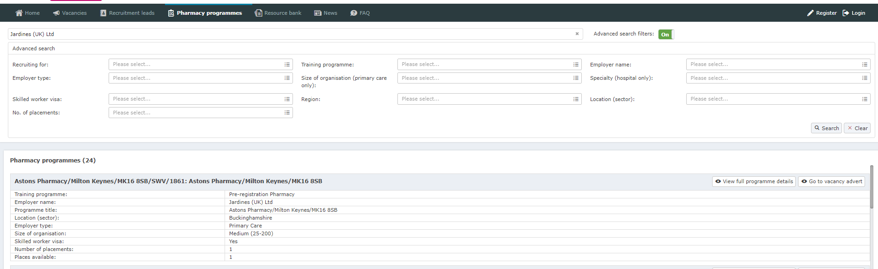
category.

4.8 Bulk preferencing
You will have the ability to move programmes in bulk from within the preferencing section of the application. This will be especially useful if you know you are not interested in a certain type of programme e.g. if you are only interested in working in primary care programmes you could use the filtering tool to show all hospital programmes and then bulk preference them into the Not Wanted category.
We would recommend that applicants who require a Skilled Worker Visa use the bulk preferencing tool to move all the programmes that cannot support their application to the Not Wanted category.

5. Processing applications and selection centres

5.1 Longlisting
The longlisting process takes place after the application window closes (from 21st June 2023 onwards) and is undertaken to check the eligibility of the applicants applying. As part of the longlisting process, you may be required to provide additional information/documentation to support your application. Please ensure that you closely monitor your Oriel account on a regular basis and respond promptly to any requests as failure to respond by specified deadlines may result in your application being withdrawn from the recruitment process.

5.2 Situational Judgement Test (SJT)/Numeracy Invitation to selection centre
All successfully longlisted applicants will be invited to attend an SJT/numeracy assessment centre. These assessments will be taken at Pearson VUE Centres, or via remote online testing in exceptional circumstances.
Pearson VUE is a multinational publishing and education company who specialise in facilitating computer-based tests and have a large number of test centres within the United Kingdom and abroad. NHS England currently use their centres for the recruitment of Dental Foundation Trainees and General Practice Trainees.
The invitation to attend an SJT/numeracy assessment will be sent via Oriel and will contain instructions on how to register and book a slot. Please note, this email is not confirmation you have a booked an assessment slot. Once you have booked a slot, you will receive an email from Pearson VUE with the booking details.
Once the invitation is received applicants will need to register and book an available appointment slot. To register applicants will need to enter the following:
- First Name* (middle name is not required)
- Surname *
- Oriel pin**
- Exam pin (will be generated on Oriel by the PNRO prior to the booking window)

*The PNRO will email you these details as you have entered them on your Oriel account, stating exactly how you should enter this information. If you do not follow these instructions the system will not accept your registration.
** Every applicant is assigned an Oriel pin when they submit an application. The PNRO will email this information to all applicants. You can also find your Oriel pin by signing into your Oriel account. This pin will also be required when you register for training with the GPhC.
Booking a Pearson VUE centre when you require reasonable adjustments.
If you have had additional time to sit the assessment agreed as a reasonable adjustment* you will have the ability to book your own slot through the Pearson VUE website. When you register on the website it will recognise that you require additional time and will only allow you to book onto slots that can facilitate your additional time.
If you have reasonable adjustments that require something beyond additional time Pearson VUE will contact you directly during the SJT booking window to arrange a suitable selection centre.
*For the full reasonable adjustments policy please see Appendix D.

Situational Judgement Test (SJT)/Numeracy Selection Centre Venues
The booking window for the SJT/numeracy assessment is between 2nd August - 16th August 2023 (STC).
To find out your nearest authorised test centre, see the Pearson VUE Test Centre search option here.
Please note all Pearson VUE selection centres are subject to change.
IMPORTANT: You need to arrive at the Pearson Vue centre to sit your SJT/numeracy assessment 15 minutes prior to the time you have booked. If you arrive more than 15 minutes late to your appointment, you may be refused admission.

5.3 Expenses
Whilst we do not reimburse expenses incurred, we do recommend that you book travel and accommodation (if needed) as early as possible.

5.4 Selection Centres – methods of assessment
The criteria that you will be assessed against at selection centres come directly from the Person Specification and Foundation Training Professional Attributes Framework (available in Appendices A, B and C). You are encouraged to read both documents thoroughly to aid in your test preparation.
IMPORTANT: All applicants are encouraged to prepare thoroughly for the process. Training packages are available, which will provide a deeper understanding of key areas of the Professional Attributes Framework. For examples, follow this link: https://www.cppe.ac.uk/programmes/l?t=Undergrad-G-01&evid=49535

Numeracy Test
The numeracy test will be taken directly before the SJT within a Pearson VUE test centre. The test is designed to test numeracy with less clinical context than the GPhC registration assessment. It will last 20 minutes.
The numeracy test is designed to provide assurance of an applicant’s ability to carry out basic pharmaceutical calculations. There are ten questions and the time allowed for the exercise is 20 minutes. These calculations are not provided in a clinical context and are designed to test mathematical ability rather than practice knowledge.
You are advised to bring your own calculator on the day of your numeracy test. Calculators will also be available online as part of the numeracy test. Please note the following:
- Only the following models are permitted by Pearson VUE:
  - Casio MX-8S-WE (this model is still permitted in the assessment although it is now discontinued)
  - Casio MX 8B-WE / MX-8B
  - Aurora HC133 (Please note this calculator is also acceptable for the GPhC registration exam)
  - Aurora DT210
- You are responsible for making sure that your calculator works on the day. You may wish to consider bringing a spare as there will be no replacement calculators provided at the test centre (however, the on-screen calculator will be available for use should you need it).
- You may not share a calculator with another candidate during your exam session.
- Your calculator will be visually inspected prior to the start of the exam. Other items, such as spare calculators, calculator covers, keystroke cards, instruction manuals, spare batteries, are not permitted in the testing room. These items must be stored in your secure locker outside of the testing room, and test centre staff will permit you to retrieve them only if needed.
- Your calculator must remain on your desk in full view throughout your exam session.
- You may not use calculators on smartphones, tablets, smartwatches, or equivalent technology.

The GPhC part 1 of the registration assessment is based upon the framework outlined in the table below. Some framework domains are more complex in nature and so better suited to developing skills in the final year of MPharm and in Foundation year. Other areas however should be developed by end of the third year of MPharm and were therefore used in the development of the numeracy assessment for the National Recruitment Scheme.
For the numeracy assessment note the following:
- You will be required to enter numerical answers only; the addition of units is not required.
- Where an answer is required to a number of decimal places, this will be clearly stated in the question text. Answers requiring a whole number input will not allow inputting of decimals and will flag as an input error. Please read the question carefully to avoid confusion

GPhC Assessment Framework Calculation Skills | Covered in National Recruitment Numeracy
Doses and dose regimens | Yes
Dosage and unit conversions | Yes
Estimations of kidney function | No
Displacement volumes and values | No
Concentrations (e.g. expressed as w/v, % or 1 in x) | Yes
Dilutions | Yes
Molecular weight | No
Using provided formulae | Yes
Infusion rates | No
Pharmacokinetics | No
Health economics | No
Quantities to supply | Yes

Situational Judgement Test (SJT)
Situational Judgement Tests (SJTs) are a measurement methodology designed to assess judgement in work-relevant situations. The Foundation Training SJT has been designed to assess the professional attributes expected of a Trainee Pharmacist. The scenarios have been written by subject matter experts who work closely with Trainee Pharmacists. This ensures that the scenarios presented are realistic and fair and provide an accurate reflection of what Trainee Pharmacists encounter in their role.
The SJT will be an online test undertaken at a Pearson VUE test centre examining five of the attributes from within the Foundation Training Professional Attributes Framework. It will consist of 52 scenarios to be completed in 104 minutes. When responding to each scenario you will be asked to place yourself in the role of a Trainee Pharmacist and indicate what you should do in response to the situation presented.
Within the SJT there will be two types of response format:
- Rank five responses in order of appropriateness in response to the scenario
- Multiple choice where you will be required to select the three most appropriate actions (out of a total of 8) in response to the scenario

Examples of both SJT response formats are available on the England and Wales Foundation Training Recruitment Student zone for you to familiarise yourself with. The PNRO will also signpost to other resources which may assist your preparation for the SJT.
The SJTs directly test the following attributes from the Foundation Training Professional Attributes Framework:
- Person-centred care
- Multi-professional collaboration and leadership
- Professional integrity and ethics
- Problem solving, clinical analysis and decision making
- Communication and consultation skills

However, as many of the attributes are interlinked, successful SJT performance requires the candidate to utilise other behaviours within the PAF that are not directly tested.
REMINDER: All applicants are encouraged to prepare thoroughly for the process. Training packages are available, which will provide a deeper understanding of key areas of the Professional Attributes Framework. For examples, follow this link: https://www.cppe.ac.uk/programmes/l?t=Undergrad-G-01&evid=49535

Sitting an SJT/numeracy assessment at a Pearson VUE Centre
You will need to arrive 15 minutes before your booked time. The Numeracy/SJT test will be sat at a computer; first the numeracy test, followed directly by the SJT. You may be sat with people who are taking non-HEE Foundation Training recruitment tests e.g., a driver theory test. All tests are sat under exam conditions, and the Pearson VUE staff will be there to assist should you have any issues on the day.
Please note all seats in the test room are near to the test room door, but if you have preference to sit as near as possible to the door, you can request this at the test centre during the check-in and the Administrator will seat you accordingly if they are able to do so.
You will be offered a whiteboard and pen during the check in process, in order to take notes during your test. This must be handed back at the end of the test session. Please note this whiteboard is not erasable; should you fill up your whiteboard, you can request another. Your original white board will need to be returned when requesting another.
No note paper of any kind is permitted.
You can find further guidance on what to expect at a Pearson VUE centre by visiting https://home.pearsonvue.com/test-taker/security.aspx

5.5 SJT/Numeracy centre documentation
You will be required to present one form of original (no photocopies), valid (unexpired) government issued ID that includes your name, photograph, and signature.
The first and last name that you used to register must match exactly the first and last name on the ID that is presented when attending on test day. Pay attention to any middle names that are included but not initially provided during registration, for example.
IMPORTANT: If the name on your passport is different to your current name, you will need to bring your original marriage certificate or other appropriate documentation and a copy of said document.
To view the full ID policy, including any additional allowances to this policy, please visit http://www.pearsonvue.com/policies/1.pdf
If you have any questions or concerns about the ID, you are required to bring with you to the testing centre for admittance for your exam please contact Pearson VUE Customer Service.
If you arrive more than 15 minutes late to your appointment, you may be refused admission.
Should your name change between the submission of your application and the sitting of your numeracy/SJT please notify the PNRO via Enquiries and Support Portal.

Feedback
If you are dissatisfied with any aspect of the recruitment process or wish to make a complaint, please contact us via Enquiries and Support Portal (please also see section 7 below).
Raising a concern or making a complaint will not negatively affect the outcome of your application.

5.6 Scoring guidance
You will receive individual feedback about your selection centre performance by no later than 30th December 2023. This will include:
- Overall score for SJT
- Numeracy score

This information will be available on your Oriel dashboard via Oriel. Please click on interview as highlighted below to view your score.
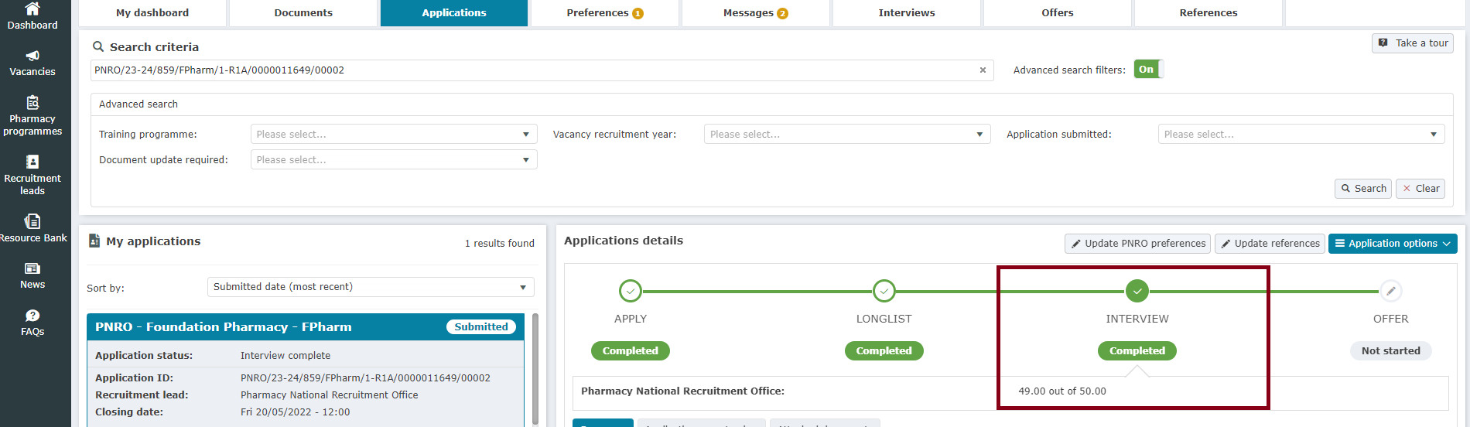

Minimum pass thresholds for the Numeracy and SJT components vary every year according to the performance of the cohort as a whole and are arrived at using an evidence-based standard setting process, including statistical analysis of the questions being asked.
IMPORTANT: If you fail to meet the pass threshold in either the Numeracy or the SJT you will be deemed unsuccessful and will not be eligible to receive an offer

Situational Judgement Test Scoring
Your SJT score will be the final score you receive as part of the pharmacy recruitment process and thus your overall rank. The raw SJT scores for pharmacy applicants are equated. This is to ensure that the final SJT score accounts for the differences between papers.
Numeracy Test Scoring
Your score for the Numeracy Test is reported on the raw scale. The range of scores available on the Numeracy Test is 0-10.
The score you receive within your numeracy test will not be included within your total score but may be used as a tie breaker.
The numeracy test will be pass/fail with applicants being required to score over a set threshold to be eligible to be made an offer. In 2022, the pass mark was 30% and it is expected that the 2023 pass mark will be similar.

Tiebreakers
Your SJT total score will be used to rank you against all applicants within the ORIEL system. Each applicant requires a unique rank, therefore in the event of a tied SJT score, various pieces of information will be used as tiebreakers until the applicants have been differentiated and can therefore be given a different rank.
The first piece of information that will be used as a tie-break will be your total score on the trial SJT items that you complete as part of the SJT. Due to these items being trial items, they do not contribute to your total SJT score, however, they measure the same attributes and are developed following the same process as the scored items.
If this score is still equal, the scores received will be differentiated using the attributes measured within the SJT. These will be based upon stakeholder rankings of the importance of each attribute.
If these scores are also tied, your score from the numeracy test will be used.
In the event of a tied score, information in the following order will be used as tie-breaks:
- SJT Trial Item Total Score
- Person-Centred Care SJT Score
- Professional Integrity & Ethics SJT Score
- Problem Solving, Clinical Analysis & Decision Making SJT Score
- Multi-Professional Collaboration & Leadership SJT Score
- Numeracy Test Score

5.7 Unsuccessful Applicants
Unsuccessful applicants will be sent communications in early November to inform them they can seek places outside Oriel.
It is natural to feel disappointed if you have been unsuccessful in the assessments. At this point if you wish to discuss your results with us you can contact the PNRO office using the contact details in Section 7 below or your School of Pharmacy.
You may also wish to speak to your School of Pharmacy or access information or support from Pharmacist Support. Pharmacist Support is an independent charity that provide a wide variety of support services to pharmacists and pharmacy students. This includes online information on finding a foundation trainee pharmacist placement and a list of job vacancy sites that students may find helpful. For your emotional support they offer a range of wellbeing resources, a Listening Friends peer support service, or a counselling service for psychological and emotional support. Please have a look at their webpages here www.pharmacistsupport.org or alternatively contact them at info@pharmacistsupport.org.

6. Offers process
Offers will be coordinated through the Oriel system by the PNRO, according to your rank and the order with which you ranked your programme preferences.
If you are ranked first, you will be offered your first preference followed by the person who ranked second being offered their first preference, unless it has already been offered to the person who ranked first, in which instance they would get their second preference and so on.

Example: How Foundation Pharmacy offers will work
Kate’s top three programme preferences were: Pharmacy A, Pharmacy B and Pharmacy C. Kate ranked 1001 following the selection centres, meaning 1000 applicants ranked higher than her. When it was Kate’s turn to be allocated, all of the programmes within Pharmacy A and Pharmacy B had been filled by higher ranking applicants. There was still a programme place vacant within Pharmacy C, therefore Kate was sent an offer for this programme.

You will be notified of offers via your Oriel account. This notification can be received at any point during the offers window, mid-November to early December.
Important: during the offers window we strongly recommend that you monitor your Oriel and email accounts (including the junk/spam folders) especially closely to ensure you do not miss notifications of offers.
You will be given 48 hours (excluding weekends and bank holidays) to accept or decline an offer (see next page). Please click here to view a video guide on how to accept your offer and opt in/out of upgrades.
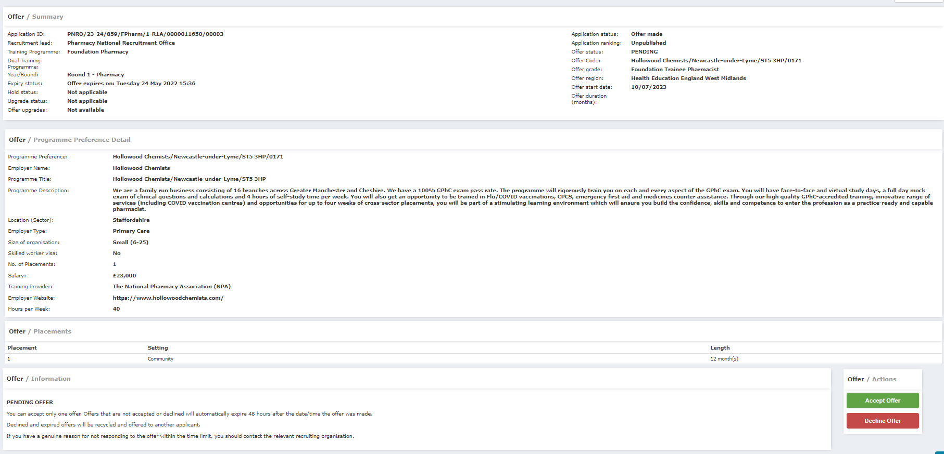

IMPORTANT:
If you decline an offer you will be removed from the process.
If you let an offer expire you will be removed from the process.
Once removed from the process you will not be eligible to receive any subsequent offers.

6.1 Offer responses
Once you have been made an offer and have signed into your Oriel account you will be given the following options:
- Accept: If you accept an offer this means you are 100% satisfied to complete your Foundation Training with this employer/host organisation. By accepting an offer on Oriel, you are agreeing to take up that post, although please bear in mind that the offer on Oriel is not a formal contract of employment. You will subsequently receive a formal contract directly from the employer/host organisation. Once an offer has been accepted you will be removed from the offers process unless you choose to opt into upgrades. (See 6.2 below). Please remember that accepting an offer which you subsequently refuse has severe implications for both employers/host organisations and other applicants who preferenced that post. Your SoP may be informed if you take this action without valid reasons for doing so.
- Decline: If you decline an offer, you will not be eligible to receive any subsequent offers. This is something to consider very carefully when preferencing; you should not preference a programme you would not be willing to accept.
- Hold: Only for applicants who have applied to both the National and Scotland vacancy (see section 6.4)

6.2 Upgrading
The Oriel system allows you to opt into upgrades when accepting an offer.
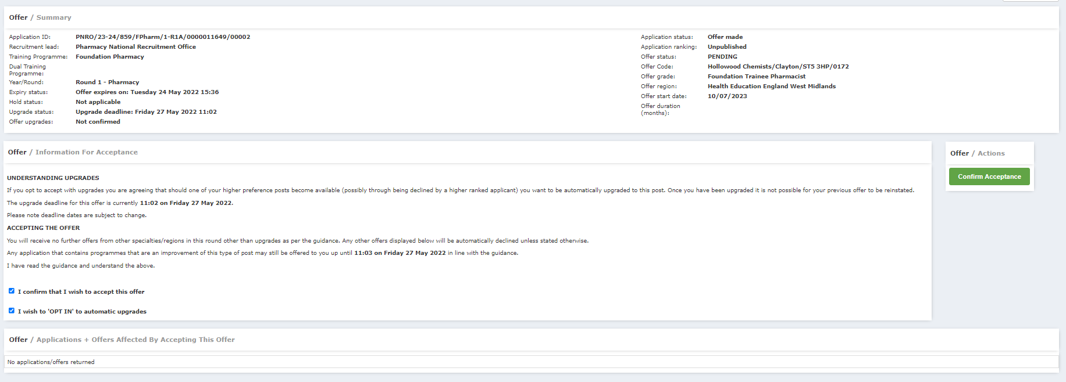
If you opt in, then should a higher ranked preference become available where an offer is accepted with upgrades, you will be automatically upgraded to this offer, if eligible, up until the upgrade deadline (end of November). If your offer is upgraded, then you cannot revert to the original offer – the original offer is completely replaced by the upgraded offer.
You will have the option to opt out of the upgrades system at any point during the offers process.
Once you have accepted an offer, the Oriel system allows you to opt in to/out of upgrades at any time until the upgrade deadline has passed.

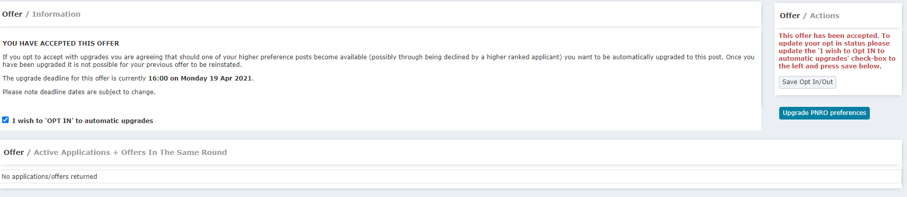
You can choose to opt in for all or some of the programmes you have preferenced higher or lower than the one you received (screen shot below) at any point up until the upgrade deadline has passed (end of November). You can also choose to opt out if you change your mind. If you opt into upgrades, and an upgrade becomes available, you do not have an option to decline the upgrade and you will not be able to return to your previous offer. Upgrades automatically replace your initial offer.
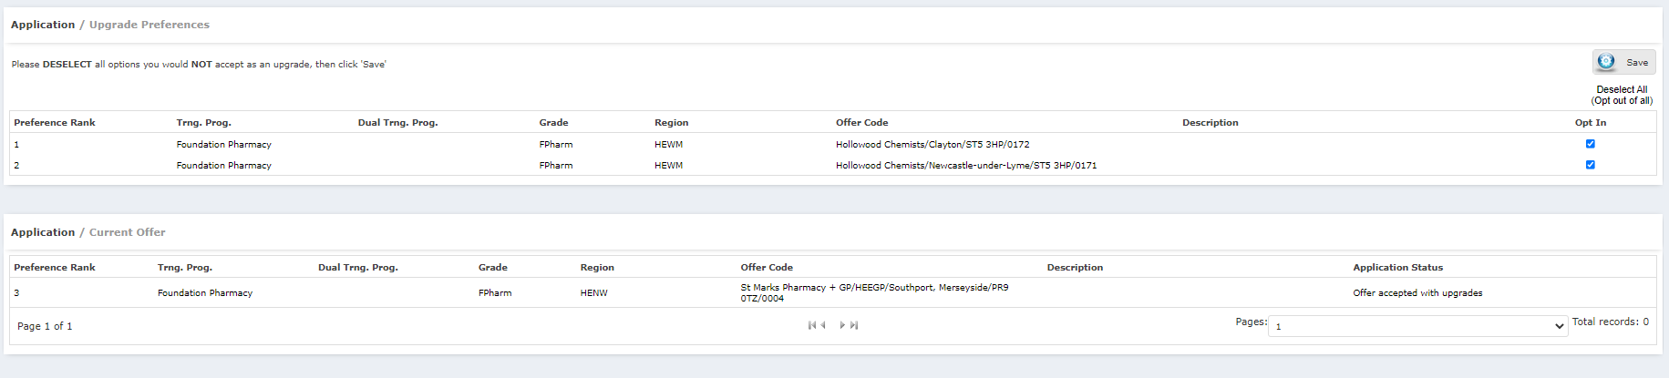
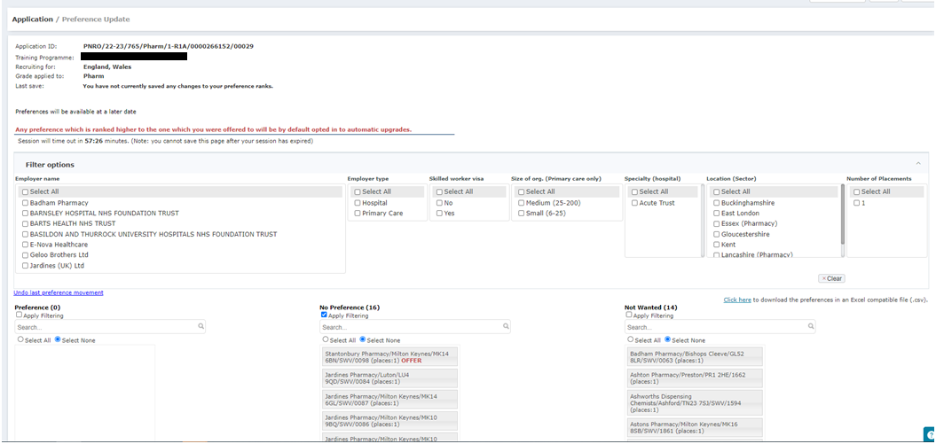
The programme you accept can be easily identified by the word ‘OFFER’ displayed in red against it. This programme cannot be moved into the ‘Not wanted’ column. Any programme that you rank HIGHER than the ‘OFFER’ programme will be considered as being opted in for upgrades. You will never receive an offer that is ranked lower than the ‘OFFER’ programme.
Please note: Upgrades are automatic when opting to hold with upgrades. If an improved preference becomes available before the upgrade deadline, the current offer will automatically be upgraded. Applicants are notified of the upgrade by message within their Oriel account. After an upgrade has been made, there is no opportunity to revert to the previously held post.

6.3 Enhanced preferencing and offers
Enhanced preferences allow applicants to amend their preferences within the 48-hour pre-determined preferencing windows. These will be communicated to applicants throughout the process, and you will be notified via Oriel when they are open and if you are successful in receiving an offer. Preference options may be briefly unavailable when recruiters are matching and preparing offers; preferencing must be closed to allow the matching to run.
Example: an applicant who is yet to receive an offer
Lauren has not yet received an offer; the upgrade deadline is yet to pass. Since submitting her preference options two weeks ago she had had a change in personal circumstances and now wishes to expand her geographical choices to include 10 more programmes. She can do this by logging into her Oriel application and adding to her preference list
Applicants who have accepted an offer will also be able to amend their preferences at any time during the recruitment process, up until the upgrade deadline for the recruitment round. Please click here, to view the different methods of amending preferences once the offer process has started.
Example: an applicant who has received an offer
Meera was offered her 12th preference position and wishes to accept the offer with upgrade. However since making her original preferences Meera’s family situation has changed and it would no longer be viable for her to travel to her 6th,7th, 8th or 9th preferences. Meera is worried that if she could be offered these through the upgrade option. Enhanced preferencing will prevent this situation happening. When Meera receives her offer she will also be able to amend her preferences i.e. she can remove preference 6,7,8 and 9 from her list completely and also add new programmes that were more local to where she needs to live.

6.4 Holding an Offer: For applicants applying to both National and Scotland Vacancies only
If you have applied to England/Wales as well as Scotland, you may be offered a place in both vacancies. Oriel will allow you to hold one offer while you decide which one to accept.
The held offer can be accepted or declined at any time up until the hold deadline. Only ONE offer can be held at any time in the same recruitment round. Trying to hold a second offer will result in the original held post being rejected. Before the hold deadline passes, offers must be confirmed as accept, accept with upgrades or decline. If you choose to hold, you will have two options:
Hold without upgrades:
- The applicant is reserving the offer
- No upgrades by preference will be made
- Offers from Scotland can still be received
- The held offer can be accepted or rejected at any time up until the hold deadline

Hold with upgrades
Applicants receiving offers which are not their first-choice preference can select the hold with upgrades option.
- The applicant is reserving the offer
- The held offer preference will be automatically upgraded if preferred preferences become available. Offers from Scotland can still be received. Applicants who opt into upgrades will have their offer upgraded without further contact being made with them
- The held offer can be accepted or rejected at any time until the hold deadline

If no action is taken, the held offer will expire and will be deemed to have been declined and will be offered to another applicant.
IMPORTANT: If you have applied to only one Oriel vacancy you must not hold; this option is only for those who have applied to both vacancies

6.5 What happens after accepting an offer
After you have accepted an offer, and the upgrade window has passed, your information will be released to the employer/host organisation whose programme you have accepted. The release of employer information will take place in December 2023.
In rare cases (for example changes in DS provision and Covid workforce pressures), employers may need to move your training location to somewhere in close proximity​.
This will only happen in exceptional circumstances; in the first instance please work with your employer to facilitate this and discuss your requirements with them. ​
The PNRO is available should you wish to contact them via the online portal

6.6 Contacting Your Employer
We would advise you to initially wait for your employer/host organisation to contact you. Please bear in mind that December is a busy period for pharmacies and so they may not contact you immediately. Please be patient and wait for them to contact you as soon as they can. However, if they have not contacted you by the beginning of February, please contact them then.
You are advised to read the information on the GPhC website on registering with them as a Trainee Pharmacist. Your application is usually required in June of the year you will start your training. Please note that you cannot start your training year until you have registered with the GPhC.
IMPORTANT: Offers are subject to employer pre-employment checks such as occupational health, immigration requirements, and satisfactory references. Pre-employment checks normally start between six and three months before the programme start date.
IMPORTANT: Accepting an offer through Oriel shows that you are 100% intending to take up that post, and therefore the employer can consider their post to be filled. Please remember that accepting an offer which you subsequently refuse has severe implications for both employers and other applicants who preferenced that post (see below). Your SoP may be informed if you take this action without valid reasons for doing so.
Accepting an offer through Oriel does not constitute an offer of employment. It is the responsibility of the employing organisation to offer you a contract of employment for the duration of your programme. Please note that service re-configuration and branch closures may result in your offer changing.

6.7 Withdrawing from an Oriel offer
In previous years there have been a number of applicants who withdrew after accepting their offer. Whilst there are valid unforeseeable reasons for withdrawing, we advise applicants to think very carefully before doing so.
Withdrawing from a programme once the Oriel offers process is complete carries a number of significant negative ramifications:
- Displays a level of unprofessionalism.
- The programme is no longer available to other applicants who wanted it.
- Leaves employers having to re-recruit at their own expense and time outside of the Oriel system.
- Potentially means taxpayers money is wasted if the place remains unfilled.
- May negatively impact upon the pharmacy’s workforce planning because you have left them without a Trainee Pharmacist
- May discourage employers from recruiting via Oriel in the future, thereby disadvantaging other students who would have wanted to apply for a post with them.

PNRO reserve the right to inform your School of Pharmacy if you renege on an offer without a valid reason for doing so.
Remember, only preference programmes you are willing to undertake and if you do not wish to accept a programme, decline it before the offers window closes so that it can be offered to another applicant.
It is also worth noting that programmes recruited to via Oriel have access to additional NHS England or HEIW support such as designated supervisor training and quality management of places.

6.8 Data Sharing
With reference to the information that you provide to us via Oriel, please be aware that your data will be used for the following purposes:
- Processing of your data during the recruitment process
- Processing of successful applicant data by NHS England local recruitment offices, Health Education and Improvement Wales (HEIW) Deaneries, Royal Colleges and employing NHS organisation
- Use of recruitment data for evaluation, research, and testing purposes, and for workforce planning and quality assurance. This may involve sharing your data with other organisations involved in these purposes such as employers/host organisations, evaluation partners, Schools of Pharmacy etc.

Full details on how your data will be stored and processed can be found by accessing the Oriel privacy policy here.

7. Enquiries
Any further enquiries should be made via the Enquiries and Support Portal. To access the pharmacy specific section, you will need to do the following:
- Select the ‘Recruitment/ Inter Deanery Transfer’ drop down arrow and then select ‘Recruitment.’
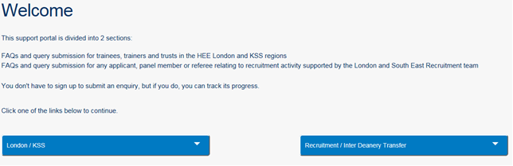
- Select ‘Applicant Enquiries’
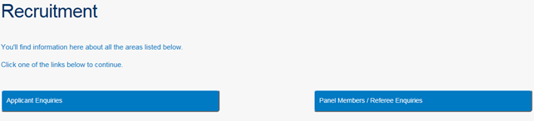

- Select the ‘Pharmacy’ drop down arrow and then select ‘FAQs’
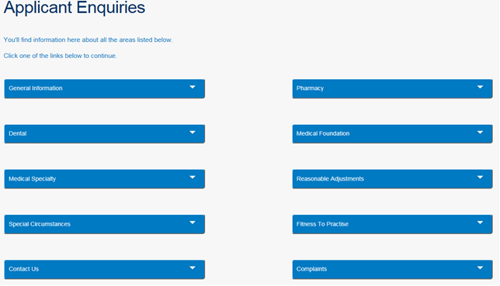
- If none of the FAQs answer your enquiry, then select the ‘What if none of the FAQs answer my query’’ option and this will allow you to submit an enquiry.

8. Useful Links
Organisation | Link
The General Pharmaceutical Council (GPhC) | https://www.pharmacyregulation.org/
Pharmacy National Recruitment Office | https://www.lasepharmacy.hee.nhs.uk/national-recruitment/
HEE Enquiries and Support Portal | https://hee.freshdesk.com/support/home
British Pharmaceutical Students Association (BPSA) | www.bpsa.co.uk
Royal Pharmaceutical Society (RPS) | https://www.rpharms.com
Visas and Immigration Advice | https://www.gov.uk/government/organisations/uk-visas-and-immigration
Pharmacist Support | https://www.pharmacistsupport.org

Appendix A: Foundation Training Person Specification 2024 entry
 | Essential Criteria | Desirable Criteria
Eligibility | Meets the requirements for Foundation Training set by the General Pharmaceutical Council at intended start date.
Knowledge | Demonstrates knowledge of the Foundation Training scheme set by the General Pharmaceutical Council.  Applies clinical knowledge in the practising environment; draws all knowledge together and builds upon what have learnt to benefit the person receiving care. | Demonstrates knowledge of Pharmacy in Practice*.  Demonstrates awareness of roles and functions of the wider pharmacy team.
Experience |  | Demonstrates experience of direct patient or public contact in a public facing role.  Demonstrates prior pharmacy related experience outside of the pharmacy qualification.
Professional Skills and Attributes | Demonstrates person-centred care*.  Demonstrates communication and consultation skills*.  Demonstrates problem solving, clinical analysis and decision-making*.  Demonstrates self-directed learning and motivation*.  Demonstrates professional integrity and ethics*.  Demonstrates an awareness of multi-professional working*.  Effectively uses mathematical skills in pharmaceutical calculations in the context of person-centred care. | Demonstrates leadership**.  Demonstrates an awareness of quality management and organisation*.  Demonstrates resilience and adaptability*.

Notes
Some of the criteria within this person specification are underpinned by behavioural indicators within the Foundation Training Professional Attributes Framework (PAF). Where this is the case, the criteria are marked with an asterisk*. The criterion marked with two asterisks** is underpinned by behavioural indicator 5.7 within the PAF. This person specification should be read in conjunction with the PAF to ensure the reader has an understanding of the full extent of the essential and desirable criteria included within it.

Appendix B: Job Description (2024 entry)
1. General Information
- Job Title: Trainee Pharmacist
- Location: Host training organisation approved for the Foundation training year by the General Pharmaceutical Council (GPhC)
- Hours of work: Normal weekly working hours of host training organisation with flexibility to meet the needs of the service. Limits of weekly working hours are specified by the GPhC.
- Overseen by: GPhC designated supervisor at host training organisation
- Accountable to: Employing host training organisation

2. Job Purpose
- A fixed term contract to meet the requirements of the GPhC to register as a pharmacist

3. Main Duties and Responsibilities
- To complete a structured training programme approved by the GPhC
- To provide delivery of patient care and pharmaceutical services under supervision
- To be aware of and work within: procedures and policies of the host training organisation, accepted standards of practice, relevant legislation and regulatory requirements
- To be responsible for self-directed learning
- To demonstrate competence as specified by the GPhC
- To participate in education and training programmes and other activities to develop knowledge and skills as part of a commitment to continuing professional development
- To review progress regularly with the designated supervisor and undertake formal progress reviews as specified by the GPhC, to identify development needs
- To undertake and support quality improvement processes
- To undertake mandatory training as deemed necessary by the host training organisation
- To practice in accordance with the professional standards set by the GPhC and Statutory Education Bodies (Health Education England and Health Education and Improvement Wales)
- To participate in weekend, bank holiday and late duty work rotas as required
- To undertake any other duties commensurate with the post

4. Additional information
All employees are required to adhere to all relevant policies and procedures of the host training organisation, including but not restricted to:

Confidentiality and Data Protection

Post holders must maintain the confidentiality of information about patients, staff and other health service business and must not disclose any information without prior permission.
Equal Opportunities, Equality and Diversity

Post holders must always fulfil their responsibilities with regards to legislation relating to equal opportunities, equality, and diversity.

Health and Safety

Post holders have a responsibility to comply with health and safety policies and procedures to maintain a safe environment for all.

Infection Control

Post holders have a personal obligation to act to reduce healthcare-associated infections (HCAIs). Where required they must comply with all measures in place to reduce HCAIs.

Risk Management

Post holders have a responsibility to report risks such as clinical and non-clinical accidents and incidents promptly via the employer’s incident reporting system.

Safeguarding children and vulnerable adults

Post holders have a responsibility for safeguarding children and vulnerable adults in the course of their daily duties and for ensuring that they are aware of the specific duties relating to this in their role.

Appendix C: Foundation Training Professional Attributes Framework (PAF)
- Person-Centred Care
  - Demonstrates empathy and seeks to view situation from the individuals’ perspective
  - Places the person who is receiving care first, in everything they do; considers each person and the care they receive in a holistic and inclusive way
  - Respects and is sensitive to a person’s current and longer-term expectations, needs and their wider social circumstances
  - Shows genuine interest in, and compassion for, the individual; makes them feel valued
  - Works in partnership with individuals, empowering and guiding every person to make informed and safe choices regarding their personal healthcare outcomes
  - Effectively manages the expectations of the person accessing care

- Communication and Consultation Skills
- Adapts approach to communication for the audience and across a variety of contexts, including virtual, written and in-person interactions
  - Identifies and interprets non-verbal cues from others
  - Effectively uses non-verbal communication
  - Recognises potential barriers to communication, considering how to communicate when non-verbal communication is limited
  - Seeks confirmation of understanding when communicating, clarifying where necessary
  - Uses appropriate questioning techniques to elicit accurate and relevant information from individuals
  - Provides accurate and clear information and advice to people receiving care and colleagues
  - Instils confidence in others through communication style
  - Effectively builds rapport; considers the differences of doing this irrespective of the environment; asks open questions and facilitates a two-way dialogue
  - Breaks down complex information in a way that can be easily understood by others
  - Actively listens to others; is focussed and attentive to what they have to say
  - Exhibits suitable levels of confidence and assertiveness when communicating; able to influence appropriately
  - Ensures that they have the relevant information before communicating
  - Considers the individual needs of the person when communicating, being mindful of the impact of differing backgrounds and circumstances

- Problem Solving, Clinical Analysis and Decision Making
  - Applies knowledge in the practising environment; draws all knowledge and data available together to consider the most effective approach for improving health outcomes for each individual person receiving care
  - Demonstrates proactivity and persistence when seeking a solution, whilst also demonstrating awareness of when sufficient information has been obtained
  - Knows where to find and access evidence-based information, or seeks to find out when uncertain
  - Undertakes a holistic and evidence-based approach to problem solving and decision making
  - Weighs up pros and cons of multiple options when problem solving and making decisions
  - Identifies the most important and relevant pieces of information timely and effectively
  - Critically appraises information; applies a questioning approach and seeks to further understand and explore rather than taking things at face value, to support clinical decision making
  - Undertakes a logical and systematic approach to problem solving; working through an issue or problem to find a solution
  - Uses mathematical skills in pharmaceutical calculations and interprets the outcomes, in the context of person-centred care
  - Recognises, considers and manages the risks in decision making, including where there is uncertainty and ambiguity

- Self-directed Learning and Motivation
  - Demonstrates curiosity, enthusiasm, commitment, a desire to learn and passion for the profession
  - Takes ownership for identifying own learning gaps and development needs; records progress and stays up to date
  - Seeks, and acts upon, advice, support and feedback to assist their own learning and development; develops and draws upon own support network across the team
  - Undertakes reflective practice; analyses and evaluates how they may have done something differently or what went well, understanding that learning is a continuous process
  - Demonstrates awareness and acknowledgement of own limitations and boundaries in relation to knowledge and competence
  - Demonstrates proactivity, initiative and willingness to take on opportunities and learn
  - Is driven to achieve the highest standards of care
  - Takes opportunities to be involved in research, audit and quality improvement activities, to support one’s own and the wider team’s learning, development and practice
  - Is motivated to ask questions and educate oneself to better understand individual needs and experiences of patients and colleagues from all backgrounds

- Multi-Professional Collaboration and Leadership
  - Understands, values and respects all roles (including their own) within the immediate and wider team, as well as team members’ skill sets and knowledge
  - Willing and able to facilitate others’ learning through sharing own knowledge/experience and/or supporting others when learning; takes a proactive role in sharing expertise around medicine
  - Builds and maintains meaningful and trusting relationships with team members and other health and social care professionals
  - Demonstrates an awareness of other team members’ workloads and pressures and adapts their interactions accordingly
  - Works collaboratively; provides assistance, support, supervision and guidance to other members of the team for the benefit of the person receiving care
  - Provides constructive feedback for both individual development and continuous improvement
  - Motivates and leads others; acts as a role model and supports others in adversity or in managing challenging situations
  - Demonstrates willingness and ability to actively learn from others
  - Demonstrates an awareness of the context, environment and available resources within the team and makes use of these through appropriate delegation to achieve person-centred outcomes
  - Takes an active role in managing conflict within the team; employs appropriate strategies to support with conflict resolution

- Quality Focussed and Personal Organisation
  - Is consistently accurate in their work and undertakes quality assurance processes, demonstrating attention to detail
  - Keeps accurate and comprehensive records (e.g., notes, labelling) for the purposes of ensuring safe and effective care
  - Good self-management; organises own time effectively to meet the required standards
  - Able to prioritise under time pressure; understands the importance of tasks and deadlines
  - Considers the best approach to take with their work to ensure the delivery of high-quality care
  - Uses information technology appropriately to effectively manage and organise work

- Professional Integrity and Ethics
  - Works within the law, ethical guidelines, and regulations, including confidentiality, consent, personal safety, and safeguarding
  - Takes responsibility for self and is accountable for ones’ own decisions, actions, or lack of actions
  - Demonstrates honesty and trustworthiness
  - Is open and honest about the mistakes they have made or when things have gone wrong
  - Is reliable and dependable in carrying out work duties and responsibilities
  - Recognises and values equality and diversity, treating everyone with courtesy, dignity and respect
  - Is prepared to challenge poor practice or behaviours, or speak up when errors or oversights or misuse of medicines are observed
  - Understands own clinical competence and works within this; is prepared to challenge if asked to do something outside of this

- Personal Wellbeing
  - Appropriately handles and reflects on difficult situations, setbacks or challenges
  - Understands own emotions during interactions with others; does not allow emotions to influence decisions
  - Recognises when and how to seek and access support from relevant people or services to promote personal wellbeing
  - Has an awareness of own personal wellbeing and what will impact this; understands what is within ones’ own control

- Adaptability
  - Responds well to long-term change, and is willing to initiate change where appropriate
  - Agile; able to adapt to sudden changes in roles, demands or environment
  - Remains calm, and is able to work effectively, in high pressured or emotionally challenging situations
  - Works autonomously within the remit of their role
  - Manages uncertain or ambiguous situations, continuing to progress with necessary tasks

- Commitment to the Pharmacy Profession
  - Understands and actively participates in the broader pharmacy landscape, how it is evolving and its position and interaction with the wider healthcare context, including how this aligns with the environmental sustainability and the global citizenship agenda, and the progression of a person’s journey through this
  - Takes responsibility for understanding the differences associated with delivery of care across all pharmaceutical settings; proactively develops skills to work across all areas
  - Demonstrates an awareness of the business and financial responsibilities within healthcare, understands the cost implications of a decision
  - Champions the pharmacy profession to others and articulates the value that pharmacists add as part of the wider healthcare team
  - Engages in broader population health issues and seeks to address health inequalities within the local community, considering the wider implications of this on pharmacy practice

Appendix D: Reasonable Adjustments (2024 entry)
Request for Adjustments – Guidance
Please note, your approval is only for the application process. Any adjustments you would require for your training post, must be discussed and arranged with your future employer
Reasonable adjustments are the practical arrangements made to provide access to the SJT and remote interviews, to ensure that no applicant is at a disadvantage on the grounds of disability or health, without changing the demands of the assessment.

You must apply for reasonable adjustments as part of the national application process also submitting any relevant supporting information by the closing date at 12:00 (GMT) on 21st June 2023. It is important to note that the Reasonable Adjustments allowed for the SJT selection assessment may differ from those you obtain for university exams.

The PNRO is aware of the requirements of the Equality Act 2010 and will make reasonable adjustments to accommodate requests provided these are made known in advance. Any requests for reasonable adjustments (e.g. wheelchair access, extra time, nursing mothers) must be submitted as part of your Oriel Application form. Adjustments cannot be guaranteed if contact is made after the specified deadline and no adjustments can be made on the day of the assessments if it has not been approved.
As part of your Oriel application form you will be asked to select the relevant adjustment and upload the supporting evidence to support the request.
To request the adjustment, you will need to answer Yes to the question “Do you have a disability which requires any specific arrangements / adjustments to enable you to attend a computer-based test, interview or assessment, or other selection process?” in the Personal Details section of the application form and select the adjustment(s) you require from the list of options along with uploading the supporting evidence.
If you have any queries regarding Reasonable Adjustments, please contact the recruitment team on https://lasepgmdesupport.hee.nhs.uk/support/tickets/new?form_17=true.

Disability Confident Scheme
If you have a disability, defined as a physical or mental impairment which has a substantial and long-term effect on your ability to carry out normal day to day activities and you meet the minimum criteria as specified in the Person Specification and you wish to be offered an interview under the *Disability Confident Scheme then it can be done at this point.
Under certain circumstances, applicants have the right to request adjustments to recruitment processes. The PNRO will consider the requests and accommodate where possible and reasonable.
Requests will be considered if you wish to request reasonable adjustments to a specific recruitment process because you:
- Have a disability as defined by the Equality Act 2010; and/or
- Have other extenuating circumstances
If you wish you apply for reasonable adjustments, you should complete this on your Oriel Application form.
Please note the following regarding Reasonable Adjustments:
- ‘Close access to bathroom’ is not an accommodation. All seats in the test room are not far from the test room door, but if an applicant has a preference to sit as near as possible to the door then they can just request it at the test centre during the check-in and the Administrator will seat them accordingly
- ‘Bathroom breaks’ as a specific request is not an accommodation. If you are approved for reasonable adjustments the breaks are included in the extra time you have been allocated

Supporting documentation – validity
You must provide valid documentation that confirms your disability and/or extenuating circumstances. In order to be valid, such documentation must be issued by a recognised authority and within an appropriate time frame.
For all disabilities bar learning disabilities, supporting documentation needs to be issued by a doctor on the GMC specialist register (this includes the GP register) in order to be considered valid.
The supporting documentation must:
- Confirm your disability
- Corroborate the rationale supplied for each adjustment requested
For learning disabilities (including dyslexia, dyspraxia, etc) valid supporting documentation consists of a standard report from an educational psychologist or University Disabilities Unit / Enablement Centre confirming investigation and diagnosis of a specific learning disability. No other documentation will be accepted.
To be considered valid, the supporting documentation must feature:
- Letterhead/ branding
- Date of issue
- Full name of candidate
- Full name, title and qualification of signatory
- Signature of signatory

Submission deadline
The deadline for submitting requests and the supporting evidence is the closing date of the application window (21st June 2023 12:00 GMT).
Requests for adjustments submitted after this date will be considered only if your circumstances have changed since the closing date of applications and there is sufficient time available before your assessment to accommodate your request. Please contact us via the Applicant Support Portal to receive further guidance: https://lasepgmdesupport.hee.nhs.uk/support/tickets/new?form_15=true

Appendix E: Foundation Training Special Circumstances Policy (2024 entry)
1. Special Circumstances
As part of the Foundation Training Recruitment Scheme there is a formal process to manage applicants with special circumstances who require placement in a certain geographical area for their training.
The special circumstances process does not, however, give applicants the option to choose the pharmacy setting they wish to work within. Applicants who have special circumstances approved may be pre-allocated to Hospital or Primary Care placements within the required region.
You can only apply for special circumstances based on your current situation. You cannot apply based on events that have not yet occurred.
All applicants must adhere to the rules of the national application process. This means that if you apply or are approved for pre-allocation on the grounds of your special circumstances, you must still complete and submit a Foundation Training application form on Oriel. You must also sit the Situational Judgement Test (SJT) and numeracy test and will be required to achieve a score that is high enough to meet the national appointability threshold. This score may also be used for matching you to a specific programme.
Please note that this guidance applies only to England and Wales. If you are applying for a post in Scotland under special circumstances please use their separate process.
1.1 Eligibility Requirements
If you satisfy one of the following criteria you will be eligible to apply for consideration of your special circumstances:
Criterion 1: you are the primary carer for someone who is disabled, as defined by the Equality Act 2010.
The Equality Act 2010 defines a disabled person as someone who has a physical or mental impairment, which has a substantial and long-term adverse effect on his or her ability to carry out normal day-to-day activities. For the purposes of the Act: -
- Substantial means more than minor or trivial.
- Long-term means that the effect of the impairment has lasted or is likely to last for at least 12 months.
- Normal day-to-day activities include things like eating, washing, walking and going shopping.
- Some conditions, such as addictions to non-prescribed substances, are specifically excluded.
- People who have had a disability in the past that meet this definition are also covered by the scope of the Act.
- There are additional provisions relating to people with progressive conditions. People with HIV, cancer and multiple sclerosis are protected by the Act from the point of diagnosis. People with visual impairments are automatically deemed to be disabled.

Criterion 2: you have a medical condition or disability for which ongoing follow up for the condition in the specified location is an absolute requirement.
Criterion 3: you have parental responsibility for a child or children under the age of 18
Criterion 1 and Criteria 2: you can apply under both criterion if you meet the requirements. In this instance, you should complete the combined form and submit it with evidence to confirm eligibility under both criterion
Joint applications will be permitted in the following circumstances:
- Shared caring responsibilities – where more than one applicant, in the same recruitment round share caring responsibilities for the same individual
- Fertility treatment – where both parties in a relationship are undergoing fertility treatment and they are applying in the same recruitment round.

Where submitting a joint application, only one application and one set of supporting evidence will need to be submitted, however, both parties must ensure that each applicant is named personally in the submitted evidence.
1.2 Assessing Eligibility and Supporting Evidence Required
If you fall into any of the above criteria, you should declare this on your application form.
You will also be required to submit your supporting evidence to the PNRO via the HEE Enquiries Support Portal. You must submit all the required evidence before the applications window on Oriel closes (21st June 2023 12:00pm GMT).
Please note this is a secure portal and any evidence submitted will only be shared with staff who require access as part of the special circumstances process.
If your circumstances change after the closing date for applications, you cannot apply for special circumstances.
IMPORTANT: In order to apply for special circumstances, you must both declare this on your Oriel application form and also submit your evidence via the Enquiries and Support Portal. Both must be submitted before the deadline of 21st June 2023 12:00pm (GMT).
The information and evidence you must provide will vary depending upon the criterion you are applying under:
Criterion 1: Primary Carer
- Criterion 1 Request for Special Circumstances form

AND
- Written statement on headed paper from a general practitioner or social services professional, dated within the last 6 months of the application date, confirming their role as primary carer for this person, together with confirmation of the disability;

Examples of evidence:

Examples of acceptable evidence:
...is registered with (xxxxxx) as a primary carer for her husband.
...is the designated primary carer for her mother.
...(xxxxx) is her only carer.
... the only carer she has.

Examples of rejected evidence:
Mr (xxxxx) is a registered carer for his son.
Miss (xxxxx) provides substantial care for her mother.
... involved in supporting and caring for her sister.
... he and his mother are the main carers for his father.
... acts as a supporting carer.

AND
- Care plan on headed paper from a general practitioner or social services professional, dated within the last 6 months of the application date. Where an official care plan is not available, details of caring responsibilities and activities should be provided, attested by the general practitioner of the person who is being cared for or Educational Health and Care Plan (EHCP) for the child being cared for or, where this is unavailable, confirmation that an assessment has taken place and that the development of the EHCP is in progress. The care plan needs to be signed and demonstrate how you will combine the responsibilities of a Trainee Pharmacist and primary carer and ensures that you have fully considered local support and resources.

Examples of evidence:

Examples of acceptable evidence:

Council produced Education, Health and Care Plan

Description of care duties required e.g. cleaning, shopping, personal hygiene, administering medication. Provided on headed paper by a General Practitioner or Social Worker who has known you for at least 6 months

Description of care duties required e.g. cleaning, shopping, personal hygiene, administering medication. Written by the applicant but attested as accurate by a General Practitioner or Social Worker who has known you for at least 6 months. Signature and organisation stamp required to confirm authenticity

Examples of rejected evidence:

Care plan written by the applicant but caring duties not attested by General Practitioner or Social Worker.

AND
- Proof of current address e.g. driving licence, utility bill dated within the last three months of the application date.

It is expected that you and the person who you care for will remain at your current address(es), and the application for pre-allocation will be to programmes local to that address. If this is not the case, relevant evidence must be supplied as to why follow up arrangements could not continue as present and proof of the location you need to relocate to.
For you to meet this criterion, you must be the primary carer for this person, who would normally be your partner, sibling, or parent. If the person you are caring for is not your partner, sibling, or parent, you will have to explain clearly and present a strong case as to why and how you have the role of primary carer for this person. If you provide care for a person as part of a group of carers, e.g. a family, you are not eligible to apply under this criterion.
Alternative evidence
It has been recognised by the Medical and Dental Recruitment and Selection (MDRS) special circumstances team that obtaining documentation from primary care services is becoming more challenging. Where possible, you should provide a written statement confirming your role as primary carer and a care plan. In light of increasing difficulty obtaining documentation to support primary carer status, a countersigned copy of the Special Circumstances – Supporting Evidence for Primary Carer form 2023 will be considered as part of the special circumstances application in the event that you has not been able to obtain a care plan or written status confirming your role as a primary carer.
The Special Circumstances – Supporting Evidence for Primary Carer form 2023 must be completed in full and countersigned by a professional from the list below. The counter signatory must have a relevant professional relationship with the person you are the primary carer for.
Examples of recognised professions include:
Chiropodist
Dentist
Nurse
Optician
Pharmacist
Social worker
Headteacher
Doctor – (either General Practitioner or treating doctor)
Allied Health Professional
Midwife

Primary Carer where the person who is being cared for is your child
If you are a Primary Carer where the person who is being cared for is your child, in addition to the completion of the Special Circumstances – Supporting Evidence for Primary Carer form 2023 please also provide the following evidence.
- The full version of the birth certificate (detailing parent(s) name(s)) for the child who you are the primary carer for. This is to confirm that you are the parent of the child they have detailed. The birth certificate must also include the full name of the child. The short version of the birth certificate which contains only the child’s details will not be accepted.
- For legal guardians, a copy of the legal document that confirms your status for the child named in the birth certificate. If you are a legal guardian, then you may submit the short version of the birth certificate.
- Letter of referral for further assessment from General Practitioner.

Criterion 2: Medical condition/disability
- Criterion 2 Request for Special Circumstances form
AND
- A report from the current medical specialist treating your condition or an Occupational Health physician The report must be provided on headed paper and must be current i.e. written for the purpose of this application. Older medical evidence will not be accepted as there is no way of the panel confirming that this is still the current situation.
- The written report must contain all the following information.
Describe the current medical condition or disability
Describe the nature of the ongoing treatment and frequency – What treatment is required? Where is this delivered? How often is the applicant required to attend hospital?
Reasons why the follow up treatment cannot be delivered elsewhere in the UK
Impact on your health and wellbeing of transferring care elsewhere
It must also include where the applicant lives in adapted housing that could not be easily replicated elsewhere, confirmation of this from the GP or local council in written form, dated within 6 months of the application deadline.
AND
- Proof of current address e.g. driving licence, utility bill dated within the last three months of the application date.

As you already have this medical condition, it is expected that you will remain at your current address, and application for pre-allocation will be to a programme local to that address.
If the request for pre-allocation is not local to your current address, relevant evidence must be supplied as to why follow up arrangements could not continue as present.

Criterion 3: Parental Responsibility
- Criterion 3 Request for Special Circumstances form
AND
- The full version of the birth certificate (detailing parent(s) name(s)) for each child. This is to confirm that the applicant is the parent of the child(ren) they have detailed. The birth certificate must also include the full name of the child. The short version of the birth certificate which contains only the child’s details will not be accepted.

AND
- For legal guardians, a copy of the legal document that confirms your status for the child named in the birth certificate. If you are a legal guardian then you may submit the short version of the birth certificate.

AND
- Statement confirming that you have significant caring responsibilities for the child(ren). This statement must be signed by someone who is in a position to confirm they have known the applicant for at least six months and has a professional working relationship* with the applicant and child(ren) and can confirm that s/he has a significant caring responsibility for a child or children under 18. This statement must be dated within six months of the application date.

AND
- Proof of current address, e.g. driving licence, utility bill dated within the last three months or council tax bill dated within the last twelve months of the application date.

*The signatory must:
- be over 18
- have a relevant professional working relationship with the applicant and their child(ren) e.g. Midwife, GP/Doctor, Head teacher, Social Worker
- not be related to the applicant by birth or marriage
- not be in a personal relationship with the applicant
- not live at the same address as the applicant.

Please note: This criterion is based on childcare. Pregnancy is not part of this criterion. An applicant whose sole circumstance is that she (or a partner) is currently pregnant will not be regarded as eligible.
It is expected that you and your child(ren) will remain at your current address and application for pre-allocation will be to programmes local to that address. If the request for pre-allocation is not local to your current address, relevant evidence must be supplied as to why caring arrangements could not continue as present.
If you and the child(ren) do not normally reside together, this should be referred to on the application form, and information supplied as to why the caring responsibilities remain equally significant.

Criterion 1 and Criterion 2: Primary Carer and Personal Medical Condition
- Criterion 1 Primary Carer and Criteria 2 Personal Medical Condition or Disability application request for Special Circumstances form

AND
The following supporting evidence must be provided for evidence of Criterion 1:
- Written statement on headed paper from a general practitioner or social services professional, dated within the last 6 months of the application date, confirming their role as primary carer for this person, together with confirmation of the disability;

AND
- Care plan on headed paper from a general practitioner or social services professional, dated within the last 6 months of the application date. Where an official care plan is not available, details of caring responsibilities and activities should be provided, attested by the general practitioner of the person who is being cared for or Educational Health and Care Plan (EHCP) for the child being cared for or, where this is unavailable, confirmation that an assessment has taken place and that the development of the EHCP is in progress. The care plan needs to be signed and demonstrate how you will combine the responsibilities of a Trainee Pharmacist and primary carer and ensures that you have fully considered local support and resources.

AND
The following supporting evidence must be provided for evidence of Criterion 2:
- A report from the current medical specialist treating your condition or an Occupational Health physician The report must be provided on headed paper and must be current i.e. written for the purpose of this application. Older medical evidence will not be accepted as there is no way of the panel confirming that this is still the current situation.

- The written report must contain all of the following information.

  - Describe the current medical condition or disability
  - Describe the nature of the ongoing treatment and frequency – What treatment is required? Where is this delivered? How often is the applicant required to attend hospital?
  - Reasons why the follow up treatment cannot be delivered elsewhere in the UK
  - Impact on your health and wellbeing of transferring care elsewhere
  - It must also include where the applicant lives in adapted housing that could not be easily replicated elsewhere, confirmation of this from the GP or local council in written form, dated within 6 months of the application deadline.

AND
- Proof of current address e.g. driving licence, utility bill dated within the last three months of the application date.

As you already have this medical condition, it is expected that you will remain at your current address, and application for pre-allocation will be to a programme local to that address.
If the request for pre-allocation is not local to your current address, relevant evidence must be supplied as to why follow up arrangements could not continue as present.

Shared caring responsibilities
- Criterion 1 joint application request for Special Circumstances form.

AND
- Valid written statement on headed paper from a general practitioner or social services professional, dated within the last 6 months of the application date, confirming both applicants as primary carers for this person, together with confirmation of the disability
Documents that refer to carer or caring responsibilities will not be accepted
Primary caring responsibilities where conditions are not classed as disabilities under the Equality Act 2010 will not be considered.

AND
- Valid care plan on headed paper from a general practitioner or social services professional, dated within the last 6 months of the application date.
Where an official care plan is not available, details of caring responsibilities and activities should be provided, attested by the general practitioner of the individual you are providing care for.

AND
- Proof of current address e.g. driving licence, utility bill dated within the last 3 months of the application date.

Fertility treatment
- Criterion 2 joint application request for Special Circumstances form.

AND
- A report written by the current medical specialist offering the treatment, on headed paper, date in the last 6 months of the application date.

AND
- Proof of current address, e.g. driving licence or utility bill, dated within the last 3 months of the application date.

For all criteria you must also provide information on where the required location is and an acceptable travelling distance. If the required location is not the same as your current address (for example, you need a Foundation Training programme close to family as they will provide childcare) please explain why you need to be placed in a different area and provide proof of the address you need to be placed within a reasonable distance of (e.g. utility bill or bank statement dated within the last three months.)
Your documents and evidence should be submitted Pharmacy National Recruitment Office via the support portal:
https://lasepgmdesupport.hee.nhs.uk/support/tickets/new?form_17=true
A national multi-professional panel will be convened to assess your eligibility against the above criteria and review the evidence you have submitted. You will be informed of the decision by email within two working days of the panel. If your application for special circumstances is declined, you will be permitted to appeal the decision with the PNRO. Appeals should be submitted within five working days and will only be considered where additional, new evidence is submitted, or you feel that due process was not adhered to.
Where new evidence is not presented, the PNRO will inform you within five working days that your appeal will not be heard.
New evidence should be forwarded to HEE Enquiries and Support Portal and will be reviewed by the national appeal panel. The decision of the appeals panel will be final.
The PNRO will communicate outcomes of appeals to you within five working days. The decision of the appeal panel is final.
1.3 Templates
Please click here to be re-directed to the templates
1.4 Timescales
All eligibility and appeal panels will be organised to ensure that there is no delay in release of offers. Please note that the panels may vary depending on which criterion you have applied under.
1.5 Preferencing for Eligible Applicants
If your request for special circumstances is approved you must only preference (i.e. place in the ‘Wanted’ or ‘No Preference’ columns on Oriel) programmes within the approved geographical area.
You must preference all available posts within that geographical area that you are able to take up, including both hospital and primary care programmes.
Where demand for places is high, there is a risk that you will not be allocated a place in your chosen geography or sector if you restrict your selection to only a few of the places available
IMPORTANT: Being approved for special circumstances does not guarantee you a programme in one sector (either hospital or community pharmacy). You are expected to preference, and may be offered, posts in any sector that fall within your required geographical area.
1.6 Allocation of Eligible Applicants
Applicants who have been approved as having a special circumstance will be pre-allocated into the geographical area of their choice, subject to the following criteria being met:
- Applicant is deemed appointable at assessment
- Applicant scores highly enough to be made an offer of a programme on the first day that offers are released.

If both of these conditions are met the applicant will be pre allocated into their preferred geographical area before the main offers algorithm is run. If you do not score highly enough to be made an offer of a programme on the first day that offers are released then the PNRO cannot guarantee that you will be pre-allocated into your required area.
Applicants are not guaranteed their highest preferenced programme within the preferred region. Special circumstances applicants will be offered the highest ranked place within the agreed geographical area (normally county level) that they would have been offered, had the normal offers process run.
Where applicants with special circumstances do not rank highly enough to be offered a place in the first round of offers they will be placed on a reserve list, pending more programmes becoming available or offers being declined. There is no guarantee of matching special circumstances applicants to preferred locations after the first round of offers has been completed. An applicant without special circumstances who has accepted a place in the preferred location of an applicant with special circumstances will not be displaced to allow allocation of the applicant with special circumstances.
When choosing a programme applicants must ensure that they meet the eligibility for those places. This includes applicants who are currently on, or will require, a Skilled Worker visa. If you require a Skilled Worker visa and have approved special circumstances then you can only take up posts where the employer has a licence to sponsor a Skilled Worker visa.
1.7 Special Circumstances Process
The following flow chart summarises the special circumstances process, assuming that the applicant meets the minimum threshold to be found appointable at assessment:
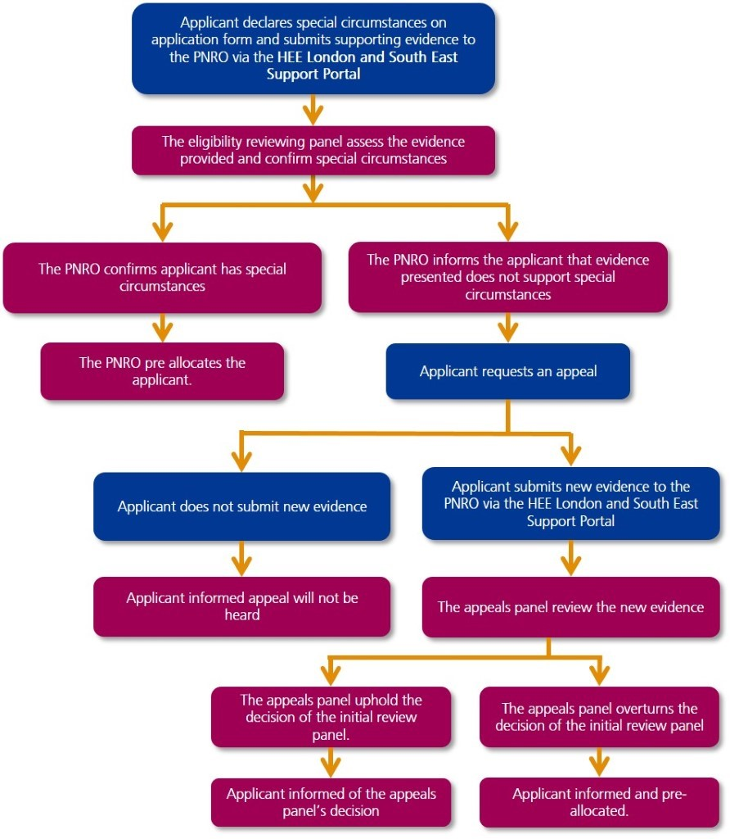

1.8 Declaration of Special Circumstances after deadlines
It is recognised that personal circumstances can change throughout the recruitment process, however, special circumstances can only be considered within the timeframes listed above.
Where applicants have a change in personal circumstances outside of the stated window, which would fall under the special circumstances criteria, they should be advised to contact their School of Pharmacy and employer (if already allocated a post on Oriel) to discuss what options are available.
If you have any queries regarding the special circumstances process, you can contact the PNRO via the Enquiries and Support Portal.

Appendix F: Regions and Sectors
Lead Geography | Region | Sector
Midlands | Health Education England  -East Midlands | Derbyshire, Leicester, Leicestershire and Rutland (Pharmacy), Lincolnshire, Northamptonshire
 | Health Education England  - West Midlands | Coventry and Warwickshire (Pharmacy), Herefordshire and Worcestershire (Pharmacy), Shropshire and Telford and Wrekin (Pharmacy), Staffordshire and Stoke-On-Trent (Pharmacy), The Black Country (Pharmacy), Birmingham and Solihull (Pharmacy)
East of England | Health Education England  - East of England | Bedfordshire, Cambridgeshire, Essex (Pharmacy), Hertfordshire, Norfolk, Suffolk
North | Health Education England - Yorkshire and the Humber | Humber Coast and Vale (Pharmacy), South Yorkshire (Pharmacy), West Yorkshire (Pharmacy), North Yorkshire (Pharmacy), Northern Lincolnshire (Pharmacy)
 | Health Education England  - North East | Cleveland, County Durham, North Cumbria, Northumberland, Tyne and Wear
 | Health Education England - North West | Cheshire, Greater Manchester (Pharmacy), Lancashire (Pharmacy), Merseyside (Pharmacy), South Cumbria (Pharmacy)
South West | Health Education England - South West | Bristol (Pharmacy), Cornwall (Pharmacy), Devon, Gloucestershire, Somerset (Pharmacy), Dorset, Bath, Swindon and Wiltshire (Pharmacy)
South East | Health Education England - Thames Valley | Berkshire, Buckinghamshire and Oxfordshire
 | Health Education England - Wessex | Hampshire and Isle of Wight
 | Health Education England - Kent, Surrey and Sussex | Kent, Surrey, Sussex, Frimley (Pharmacy)
London | Health Education England - London | East London, North Central London, Northwest London (Pharmacy), South London
Wales | Wales | Anglesey, Conwy, Denbighshire, Flintshire, Gwynedd, Wrexham
 |  | Powys
 |  | Carmarthenshire, Ceredigion, Pembrokeshire
 |  | Bridgend, Neath Port Talbot, Swansea
 |  | Blaenau Gwent, Caerphilly, Monmouthshire, Newport, Torfaen
 |  | Cardiff, Vale of Glamorgan
 |  | Merthyr Tydfil, Rhondda Cynon Taff

NHS England
Wellington House
133-155 Waterloo Road
London
SE1 8UG

This publication can be made available in a number of alternative formats on request.
© NHS England 2023 | Foundation Pharmacist Recruitment Applicant Handbook Version 1

